Пошаговая подготовка к письменной части ОГЭ по английскому языку. Раздел «Грамматика»

Автор: Гордеева Наталья Филипповна

2023 г

Пособие «Пошаговая подготовка к письменной части ОГЭ по английскому языку. Раздел «Грамматика»» адресовано девятиклассникам, планирующим получить высокий балл на экзамене. Пособие направлено на отработку навыков, а также на закрепление способов и приёмов решения вызывающих трудности экзаменационных заданий ОГЭ, как под руководством учителя, так и самостоятельно. Пособие содержит необходимый теоретический материал для подготовки к экзамену
ПИСЬМЕННАЯ ЧАСТЬ . ГРАММАТИКА
В данной работе будут рассматриваться вопросы по следующим темам:

Личные формы глаголов действительного залога: Present Simple, Future Simple и Past Simple, Present Continuous и Past Continuous, Present Perfect и Past Perfect
Личные формы глаголов страдательного залога Present Simple Passive, Future Simple Passive и Past Simple Passive
Глаголы TO BE, CAN / Оборот there + be.
Согласование времен
Условные предложения (все типы)
Имена существительные во множественном числе, образованные по правилу, и исключения
Местоимения: личные (в именительном и объектном падежах, а также в абсолютной форме), притяжательные, возвратные
Имена прилагательные (наречия) в положительной, сравнительной и превосходной степенях, образованные по правилу, а также исключения
Числительные количественные, порядковые
Герундий
Разделительные вопросы / Вопросы к подлежащему

Вопросы базового уровня сложности
Первое задание по грамматике представляет собой связанный текст, в котором есть пропуски. Нам требуется заполнить 9 пропусков правильной грамматической формой слова, приведенного в самом задании. Задание содержит в себе шесть вопросов базового уровня сложности и три вопроса повышенного уровня сложности.

К базовому уровню сложности можно отнести пропуски, требующие только знания правильной грамматической формы и не требующие дополнительного анализа контекста. Наиболее частотными вопросами базового уровня являются вопросы по следующим темам:

- существительные: слова-исключения множественного числа

- прилагательные / наречия: положительная, сравнительная и превосходная степени, образованные по правилу, а также исключения
- местоимения: личные, притяжательные и возвратные

- числительные: порядковые

Для начала мы повторим правила по данным темами и рассмотрим некоторые примеры из заданий подготовительных материалов.

ГРАММАТИЧЕСКИЙ СПРАВОЧНИК (базового уровня сложности)

Singular and plural nouns
Ед. и мн. число существительных
После  существительных добавляем - S | После  ch, s, z, sh или x  добавляем - es |  | После - f или - fe  удаляем - f / fe  добавляем - ves
a sticker – stickers a coat – coats an uncle – uncles | a branch – branches a glass – glasses a quiz – quizzes a brush – brushes a fox – foxes |  | a leaf – leaves a life – lives  a scarf – scarves a knife – knives  Exceptions:  a roof – roofs a cliff – cliffs
 |  |  | a proof – proofs a chief – chiefs
 |  |  | a handkerchief – handkerchiefs
 |  |  | ***a dwarf – dwarfs / dwarves
После гласной + y добавляем – S | После согласной + y  удаляем - y  добавляем – ies |  | Исключения
a toy – toys | a country – | countries | a man – men  a woman – women a child – children an ox – oxen  a mouse – mice a louse – lice a foot – feet  a tooth – teeth a goose – geese  a person – people
a day – days | a city – | cities
a key – keys | a butterfly – | butterflies
После гласной + O добавляем – S | После согласной + O добавляем - ES |  | Без изменений
 | a tomato – tomatoes |  | a sheep – | sheep
a radio – radios | a potato – potatoes |  | a deer – | deer
a video – videos | a hero – heroes |  | a bison – | bison
a kangaroo – kangaroos | an echo – echoes |  | a fish – | fish
a zoo – zoos | a volcano – volcanoes |  | an aircraft – | aircraft
a stereo – stereos | Исключения: |  | a series – | series
 | a photo – photos |  | a species – | species
 | a kilo – kilos
 | a piano – pianos

  - Некоторые существительные употребляются только в единственном числе:

money, sugar, hair, information, fruit, progress, news, peace, love, knowledge, advice, furniture.

  - Существительные, которые употребляются только во множественном числе: trousers, glasses, scissors, shorts, clothes, goods
  - Собирательные существительные, обозначающие группу как единый коллектив, согласуются с глаголом в форме единственного числа. Если же такие существительные обозначают отдельных представителей группы, то глагол-сказуемое употребляется в форме множественного числа.
His family is not very large.

His family are at the table. Его семья ( все члены) – за столом.

- Однако такие собирательные существительные, как people, police, cattle всегда употребляются с глаголом только во множественном числе.
The police are looking for the thief.

Examples:
- “That must be Tracey,” “Hello, Tracey!”, “Welcome, Tracey!”
the in the room welcomed her. CHILD

- Their fathers were successful who Anna sometimes BUSINESSMAN
saw on TV.

- It was a hard job and very few worked as bus drivers WOMAN
in those days but Dana loved loved her job very much.

- She was one of those rare girls who never screamed when she saw spiders,
and frogs. MOUSE

- Next he added cucumbers and . TOMATO

- “No, pink is either for or for silly girls who like Barbie BABY
dolls. I’m neither of those.”

- She loved the smells, the changing , and the cool breezes. LEAF

- When he returned from his last trip, he brought several large with him.
BOX

- My were always cold. FOOT

Положительная, сравнительная и превосходная степень прилагательных / Comparatives and Superlatives

 | Положительная степень | Сравнительная степень | Превосходная степень
Односложные прилагательные | short  nice | shorter  nicer | the shortest  the nicest
 | big hot thin  fat | bigger hotter thinner  fatter | the biggest the hottest the thinnest  the fattest
 | easy heavy | easier heavier | the easiest the heaviest
Наречие | early quickly | earlier  more quickly | the earliest  the most quickly
Многосложные прилагательные | successful interesting | more successful more interesting | the most successful the most interesting
Исключения | good (well)  bad (badly) much/many  little far | better worse more less  farther/further | the best the worst the most the least  the farthest / the furthest

  - Случаи использования сравнительной степени в предложениях:

сравнительная степень + and +  сравнительная степень для выражения увеличения или уменьшения чего-либо. | The weather is getting hotter and hotter.  Cars are becoming more and more expensive.
(very) much, a lot, (намного), a little,  a (little) bit,(немного) , far (гораздо) , slightly (немного) ,even (ещё) + сравнительная  степень  для усиления смысла | This house is a little cheaper.  Этот дом немного дешевле.  This book is far more interesting than that one. Эта книга гораздо интереснее, чем та.  She isn’t much younger than me. Она не намного моложе меня.
Слово than употребляется только при сравнения двух предметов или людей, в ином случае оно опускается. | I want a faster car.  Let’s go by car. It’s cheaper.

  - Случаи использования превосходной степени в предложениях:
Примеры использования превосходной степени в предложениях помимо использования - of/in: | She is the best student in the class. Bob is the cleverest man of all.  It is the funniest story I have ever heard.  Lack of money is our biggest problem.
Перед превосходной степенью часто употребляется by far – вне всяких сомнений  или easily – бесспорно | It’s by far the most expensive car in the world. It’s easily the most expensive of all the cars I’ve  seen.

Examples:
- It was definitely than the stewed vegetables his GOOD
mum cooked almost every day

- And there is nothing than forest fires!” DANGEROUS

- It was to walk along the top of a hill than along EASY
the bottom.

- Everyone seemed friendly and Tracey felt a little . GOOD

- Your mum showed us your photo, but you are much there. YOUNG

- “A designer’s advice is much than we can afford.” EXPENSIVE

- When the teacher handed out the tests, Bella felt even than she had felt before.
BAD

- Vicki was a year and more experienced in arranging parties. OLD
- “If you were a couple of years , you could manage it. OLD

- The weather was getting every hour. BAD
- “It’s getting every minute,” said Gary. “How about a swim?” HOT

- I grew older but the situation didn’t get any . GOOD

- I quickly looked over at my brother, Paul. He gave me YOUNG
a knowing smile.

- ***Actually, she read than most school pupils. WELL
- *** The next day Jane and her mum went to the park than usual. EARLY

**********************************

- He was the teacher in the world! GOOD

- Linda and Kate were the girls in the class. POPULAR

- I think it’s the language I have ever learnt, DIFFICULT
but it’s interesting

- Only two months before she had thought she was the
girl in the world.

LUCKY

- My friend, Nicky, believes that I spend too much time GOOD
online, on social networks.

Pronouns / Местоимения
Personal pronouns  Личные местоимения |  | Possessive pronouns Притяжательные местоимения  Относительная форма | Possessive pronouns Притяжательные местоимения  Абсолютная форма | Reflexive pronouns  Возвратные местоимения
Subject pronouns  (Именительны й падеж) | Object pronouns  (Объектный падеж)
I | me | my | mine | myself
you | you | your | yours | yourself
he | him | his | his | himself
she | her | her | hers | herself
it | it | its | - | itself
we | us | our | ours | ourselves
you | you | your | yours | yourselves
they | them | their | theirs | themselves
will come. | Bob sees .  Look at ! | It is house. | The house is . | I cut myself.
В предложении являются  подлежащим | В предложении являются  дополнением | Употребляется с определяемым сущ. В предложении – определение | Употребляется без определяемым сущ В предложении – определение | Действие направлено на лицо, выраженное подлежащим.  Переводятся  частицей –сь(-ся), которая  присоединяется к глаголам.

Examples:
  - “It’s dog." said Robbie. I
  - When I bought it, it didn’t cost very much. I
  - “Oh, nothing! I want to go shopping today and wondered if you wanted to

go with
  - “Yes, it was probably rude of
.” I
to tell those ladies that I

I wouldn’t bring them anything else.
  - Yes, in my opinion, the school uniform had more advantages than
disadvantages. was dark green. It was unfashionable I
but comfortable.
  - “Let see,” Jenny opened her bag and pulled out a pen. I

  - They are coming to help . WE
  - “Do you remember last trip?” WE
  - We knew that he loved _ a lot but he was really a very busy person. WE

  - And he let fish go. HE
  - It took several days to learn how to use it. HE
  - Jane quietly sat down on the chair beside . HE

  - One afternoon when the parents were out of the house, Matilda put on
dress and shoes and went to the library. SHE

  - I thought that visiting
I felt nervous and scared.
would be great fun, but SHE

  - The theatre has changed several times during history. IT
The building we can see today opened.

  - Tim coughed to attract _ attention THEY
  - She was sure it would impress and would help her popularity THEY
  - “And how is your new school?” she asked, still admiring the fresh
wallpapered walls with a few framed photos on . THEY
  - Some of come as tourists, others choose this place to THEY
study or to work in.
  - It was decision. THEY

    - Reflexive Pronouns / Возвратные местоимения

  - Veronica had never tried to make a pie , SHE
but she knew how, as she had seen how her mother made it many times.

  - “Have you ever fought a fire ?” a red-haired boy asked. YOU
“Yes, many times, unfortunately,” Uncle Jim answered.

  - He is too small yet and cannot read . HE

  - We kept fishing till noon but I didn’t catch anything _ I
and got really bored with it.

Количественные / Порядковые числительные

от 1 до 12  - one first  - two second  - three third  - four fourth  - five fifth  - six sixth  - seven seventh  - eight eighth  - nine ninth  - ten tenth  - eleven eleventh  - twelve twelfth от 13 до 19  - thirteen thirteenth  - fourteen fourteenth  - fifteen fifteenth  - sixteen sixteenth  - seventeen seventeenth  - eighteen eighteenth  - nineteen nineteenth | от 20 до 90 (десятки)  20 twenty twentieth  30 thirty thirtieth  40 forty fortieth  50 fifty fiftieth  60 sixty sixtieth  70 seventy seventieth  80 eighty eightieth  90 ninety ninetieth  от 21 до 99 (отдельные примеры)  21 twenty- one twenty-first  23 thirty-two thirty-second  43 forty-three forty-third  54 fifty-four fifty-fourth  65 sixty-five sixty-fifth  76 seventy-six seventy-sixth  87 eighty-seven eighty-seventh  - ninety-eight ninety-eighth  - ninety-nine ninety-ninth  - a (one) hundred a (one) hundredth  - a (one) hundred and one a (one) hundred  and first

Examples:
- She went straight into her grade classroom. FIVE

- By the end of my winter in Canada, I felt confident on the ice. ONE

- When they said that for the time, I lost control. FOUR

- My house will be smarter than the first one. TWO

- At first, making a party to celebrate her birthday FIFTEEN
looked like an easy thing to do.

- The wave hit him hard and he lost his balance. Everything THREE

- At the beginning of the century, academics became interested TWENTY
in Cornish and started to study the ancient texts.

Practice:
- It was about 6pm when I heard a knock on the door. It Jason, BE
my teenage neighbour. He looked cold and upset. “What’s wrong, Jason?”
“I _ my key and I can’t get into my house.” LOSE
“Come in. Today’s not a day for long walks, or long waits,”
I looked out the window. It hard and it was windy. SNOW
The weather was getting every hour. BAD
Jason off his coat and boots. TAKE His were wet and I gave him a pair of socks to change into. FOOT A cup of hot tea and some biscuits soon made the boy feel warm.
“Where are your parents, Jason?”
“I . NOT/KNOW
I can’t call them because of this,” he pulled his phone out of his pocket and
showed it to me – the screen and the phone was BREAK

obviously dead. Jason focused on the food again. He took his biscuit and said: “I wish my mum could make biscuits like this.”

FOUR

- By today’s standards, my mobile phone is pretty basic. It’s a Nokia. It’s a small device that receives telephone calls and sends text messages.
Other than that, my phone much. Most of my NOT/DO friends wish they smartphones because they are cool HAVE and trendy. They say the thing about a smartphone is that you GOOD ‘can do everything with it!’ That’s right, smartphones have many more
functions than a simple phone, however, not all of them are needed. In
everyday life, smartphones mainly for checking USE
social networking sites, replying to emails, and playing games. Grown-ups as
well as like playing games. Anyway, I prefer my good CHILD old Nokia. It’s my mobile phone. When I bought ONE it, it didn’t cost very much. And I am not afraid anyone will I ever steal it. It’s also very reliable. Yesterday I dropped it. It _ FLY down the staircase and hit the wall. I thought that the end of it. BE But nothing of the kind – it still works properly!

- Kate called me early in the morning. It was the day of TWO
holidays; I felt angry with her for waking me up.
“What ?” I didn’t sound very polite, but she paid no HAPPEN
attention to that.
“Oh, nothing! I want to go shopping today and wondered if you wanted to
go with .” I
“No, I don’t want to.”
“But it you long! I promise”. NOT/TAKE My first impulse was to say “no” – unlike most I hated WOMAN hated shopping. But Kate sounded so unhappy that I felt sorry for her.
“Ok, what do you need to buy?”
Kate’s voice cheerful again. She excitedly explained BECOME to me that she to buy a pair of hiking boots and a raincoat. WANT That strange as Kate had never been fond of hiking. BE
“I want to take up hiking as a new hobby,” went on Kate. “Bob Smith says that it’s very exciting.”
Now I knew what was going on. Bob Smith, the captain of the school
baseball team, was the boy in our school. All the POPULAR
girls wanted to attract his attention.

Вопросы повышенного уровня сложности
К повышенному уровню сложности можно отнести вопросы по следующим темам:

- Личные формы глаголов действительного залога: Present Simple, Future Simple и Past Simple, Present и Past Continuous, Present и Past Perfect

Личные формы глаголов страдательного залога:
Present Simple Passive, Future Simple Passive и Past Simple Passive

Глаголы TO BE, CAN (Present, Past) / Оборот there + be.
- Предложения с I wish

Типы условных предложений (0,1,2,3)
- Придаточные предложения времени

Согласование времён. Прошедшее согласование.
- Герундий

Разделительные вопросы
- Вопросы к подлежащему

Чтобы поставить глагол в правильную временную форму необходимо выполнить 2 основных шага:

Шаг1. Находим подлежащее в предложении с пропуском.
Форма глагола, выражающего действие, в английском языке зависит от того, кто(что) выполняет это действие.

Example:
Amy was shopping. She was trying on new outfits when her mobile
phone suddenly . RING

Анализируя предложение с пропуском, мы можем разделить его на две части: (1) She was trying on new outfits (2) when her mobile phone suddenly (RING). Нас интересует только вторая часть, в которой мы легко можем увидеть подлежащее – her mobile phone – именно этот предмет выполняет действие «звонить». Для себя мы также можем отметить, что фразу her mobile phone мы можем заменить на местоимение it.

Шаг2. Определяем залог, время и тип действия.
- Для начала нам нужно понять, наше подлежащее самостоятельно выполняет действие или действие выполняется над человеком/предметом, являющимся нашим подлежащим. В зависимости от этого мы берём форму активного или пассивного залога соответственно.
- Далее мы смотрим на всё предложение (а при необходимости и на соседние предложения) и определяем время, в котором происходит действие – настоящее, прошедшее или будущее. В зависимости от этого временного контекста, мы будем выбирать категорию Past, Present или Future.
- Наконец, мы оцениваем, к какой категории относится наше действие –

Simple, Continuous или Perfect.

В нашем случае с мобильным телефоном мы можем сказать следующее:
  - телефон звонит сам, следовательно, нам нужен активный залог;
  - все действия происходят в прошлом (Amy was shopping, She was trying on), следовательно, выбираем Past;
  - данное предложение является одним из случаев употребления Past Continuous: действие, которое происходило в прошлом (She was trying on new outfits), было прервано другим одномоментным кратким действием. Это краткое действие употребляется в Past Simple. Следовательно, наш ответ будет RANG.

ГРАММАТИЧЕСКИЙ СПРАВОЧНИК
(повышенного уровня сложности)
Личные формы глаголов действительного залога:
Present Simple, Future Simple и Past Simple, Present и Past Continuous, Present и Past Perfect

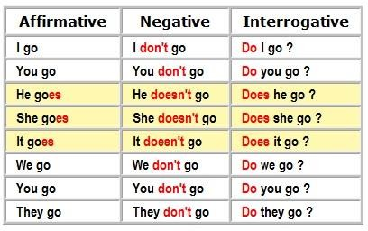
Present Simple

Do you speak English? Yes, I do / No, I don’t.

Do boys speak English? Yes, they do / No, they don’t.

Does Mary speak English?
Yes, she does / No, she doesn’t.

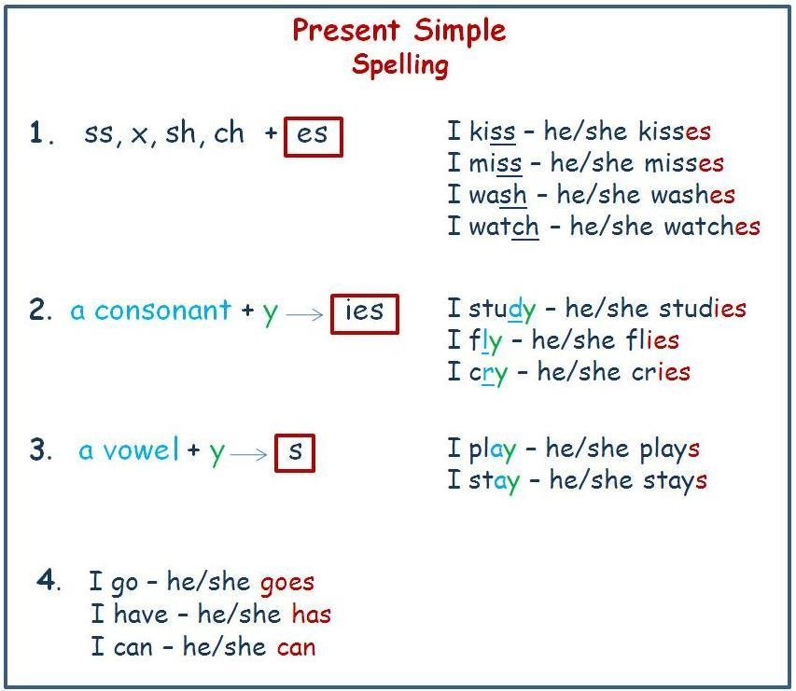
согласная
гласная
Signal words: usually, often, sometimes, seldom/rarely, always, never, every day (week,…), on Mondays

We always get up early. He is usually late for work. Do you often go to the park?

Употребление :
- Повседневные действия: Every morning I drink coffee.
- Привычки: John plays tennis on Sundays.
- Факты, законы природы: The Moon goes around the Earth.
- Расписание: Our plane leaves at 10 am.

Past Simple
Verbs: regular (play-played) and irregular (swim – swam)

Affirmative | Negative | Interrogative
I  You  He played.  She swam.  It We They | I  You  He didn’t play.  She didn’t swim. It  We They | I  you  he play?  Did she swim? it  we they
Did you play football? – Yes, I did. / No, I didn’t.
Did boys swim in the river? - Yes, they did./ No, they didn’t. Did mum cook pasta? – Yes, she did. / No, she didn’t.

Spelling (regular verbs)
  - Удвоение согласной: stop – stopped; travel – travelled
  - Если глагол оканчивается на - y: carry – carried; play – played
  - Если глагол оканчивается на - e: live- lived; move - moved
Signal words: yesterday, the day before yesterday;
last week/month , a week/two months ago; in 2003

Употребление:
- Привычное действие в прошлом: He wore glasses when he was young.
- Законченное действие в прошлом: He phoned his friend last Monday.
- Последовательные действия в прошлом: He got up, made breakfast and went to work.

Наиболее часто употребляемые неправильные глаголы в заданиях:
BE - WAS/WERE – BEEN | FEEL – FELT – FELT | SEE – SAW – SEEN
BECOME – BECAME - BECOME | FIND – FOUND – FOUND | SEND – SENT – SENT
BEGIN – BEGAN – BEGUN | FLY – FLEW – FLOWN | SHAKE – SHOOK – SHAKEN
BREAK – BROKE – BROKEN | FORGET – FORGOT –  FORGOTTEN | SHINE – SHONE –SHONE
BRING – BROUGHT –BROUGHT | GIVE – GAVE – GIVEN | SPEAK – SPOKE - SPOKEN
BUILD – BUILT – BUILT | GO – WENT – GONE | TAKE – TOOK – TAKEN
BUY – BOUGHT – BOUGHT | HAVE – HAD – HAD | READ – READ – READ
CATCH – CAUGHT - CAUGHT | HEAR – HEARD – HEARD | TELL – TOLD – TOLD
CHOOSE – CHOSE - CHOSEN | KEEP – KEPT – KEPT | THINK – THOUGHT –THOUGHT
COME – CAME – COME | KNOW – KNEW – KNOWN | UNDERSTAND – UNDERSTOOD -  UNDERSTOOD
DO – DID – DONE | LEAVE – LEFT – LEFT
DRAW – DREW – DRAWN | LOSE – LOST – LOST | WRITE – WROTE –WRITTEN
DRIVE – DROVE –DRIVEN | MAKE – MADE – MADE
EAT – ATE –EATEN | RUN – RAN – RUN
FALL – FELL – FALLEN | SAY – SAID – SAID

Future Simple

Affirmative | Negative | Interrogative
I  You He  She will swim. It  We They | I  You He  She won’t swim. It  We They | I  you he  Will she swim? it  we they
Will you play football? – Yes, I will. / No, I won’t.
Will boys swim in the river? - Yes, they will./ No, they won’t. Will mum cook pasta? – Yes, she will. / No, she won’t.

Signal words: tomorrow, the day after tomorrow, next…, in a week, in 2050

Употребление:

- Спонтанные решения: I like this dress. I will buy it.

- С глаголами hope, think, expect, believe, be sure: I think he will come.

А также с наречиями perhaps, certainly , probably : Perhaps I will tell you the truth.

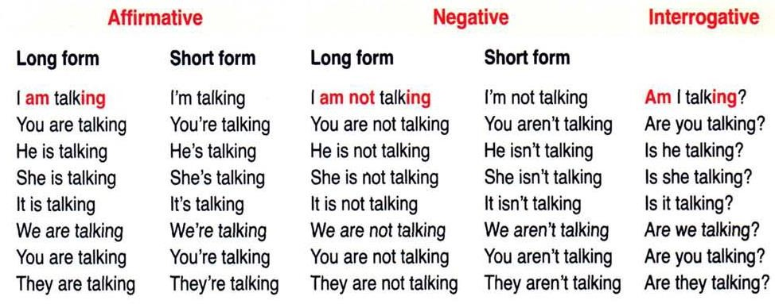
Present Continuous
Are you talking? – Yes, I am / No, I am not Is Mark talking? - Yes, he is / No, he isn’t
(Yes, we are / No, we aren’t) Are they talking? - Yes, they are / No, they aren’t
Are boys talking? - Yes, they are / No, they aren’t

Spelling
- Удвоение согласной: swim – swimming ; sit – sitting; stop – stopping
begin - beginning ; travel - travelling
- Если глагол оканчивается на - y : study – studying; play – playing
- Если глагол оканчивается на - e : drive – driving; make – making
- Если глагол оканчивается на - ie : die – dying; lie – lying

Signal words:
now, right now, at the moment, at present, these days, this week, today, Look! Listen!
I am reading now. He is working hard this week. Look! He is windsurfing.

Употребление:
  - Действие в момент речи: Jane is doing her homework now.
  - Запланированное действие: She is buying a car tomorrow.
  - Раздражающее действие с always: She is always shouting at me.
  - Постоянно меняющаяся ситуация: His English is getting better.

Past Continuous
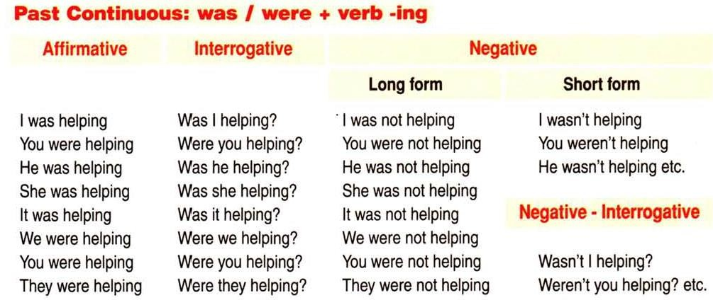
Were you helping? – Yes, I was / No, I was not Was Mark helping? - Yes, he was. / No, he wasn’t
Were they helping? - Yes, they were. / No, they weren’t

Spelling
  - Удвоение согласной: swim – swimming ; sit – sitting; stop – stopping
begin - beginning ; travel - travelling
  - Если глагол оканчивается на - y: study – studying; play – playing
  - Если глагол оканчивается на - e: drive – driving; make – making
  - Если глагол оканчивается на - ie : die – dying; lie – lying

Signal words: at 3 o’clock yesterday, while / when ,
this time yesterday

Употребление:

Действие , происходившее в определённое время в прошлом:
They were sleeping at 7 am yesterday.

Одновременные действия в прошлом:
He was listening to music while she was watching TV.

Действие, которое происходило в прошлом ,было прервано другим одномоментным кратким действием.:
I was reading when my mum came in.

Present Perfect
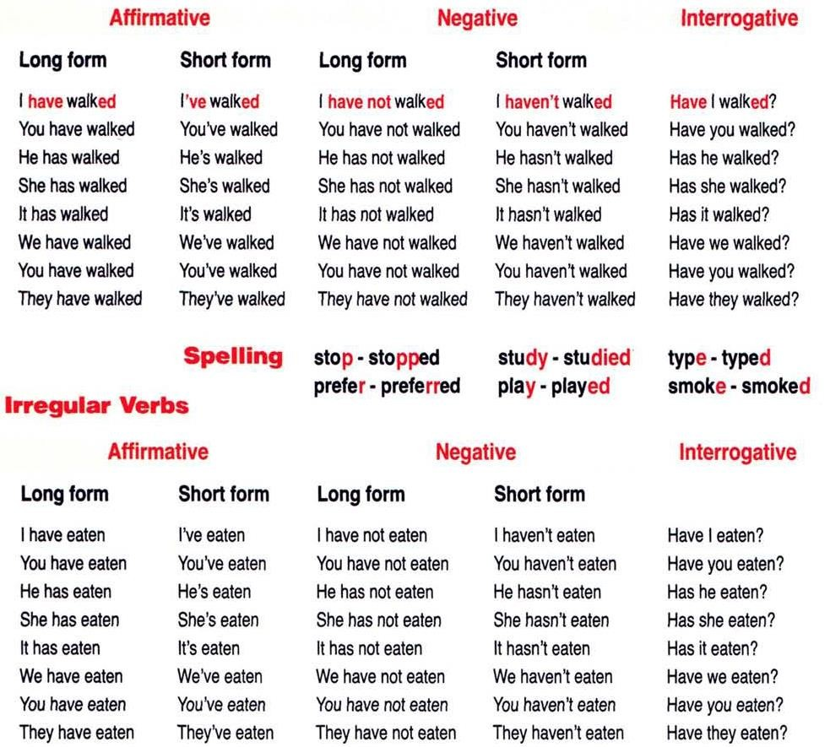
Signal words: just, already, yet, ever, never, how long, recently
since, for, so far, this morning / evening, today

Употребление:

- Действие происходило в неуказанное время : Look! I have bought a new car.
- Действие, которое завершилось совсем недавно : I have just painted the room.

Past Perfect had + V3
Past Perfect — прошедшее совершенное время, которое обозначает действия, уже закончившегося до определенного момента в прошлом.
Signal words: already, yet, never, since, for,
by 3 o’clock , before, when I came

Present Perfect  Настоящее Совершенное время | Past Perfect  Прошедшее Совершенное время
Показывает, что действие произошло в прошлом, неизвестно и неважно когда именно, но результат его виден в настоящем:  My brother feels hungry. He has not eaten since morning. – Мой брат голоден. Он не ел с утра. | Показывает, что действие произошло в прошлом и стало причиной, привело к тому, что произошло другое действие в прошлом:  My brother felt hungry. He had not eaten since yesterday. – Мой брат был голоден. Он не ел со вчерашнего дня.
Указывает на то, что действие, выраженное временем Present Perfect, завершилось к настоящему моменту совсем недавно:  The shopping center has already opened.  Торговый центр уже открылся.. | Указывает на то, что действие, выраженное временем Past Perfect, произошло раньше другого действия или определенного момента в прошлом:  When we arrived, the shopping center had already opened. – Когда мы пришли , торговый центр уже открылся..

Данные временные формы очень схожи: они обозначают действие, завершенное к определенному моменту времени. Первое неразрывно связано с настоящим (сейчас), а второе – с прошлым (тогда).

Общая таблица для глагола-связки TO BE и CAN
Present

Affirmative | Interrogative | Negative
I am big. ( I’m) He is big. (He’s) She is big. (She’s )  It is big. (It’s) You are big. (You’re) We are big. (We’re)  They are big. (They’re) | Am I big? Is he big? Is she big? Is it big?  Are you big? Are we big? Are they big? | I am not big. He is not big. She is not big. It is not big. You are not big.  We are not big. They are not big.
is not = isn’t
are not = aren’t
Affirmative | Interrogative | Negative
I can swim. He can swim. She can swim. It can swim. You can swim. We can swim.  They can swim. | Can I swim? Can he swim? Can she swim? Can it swim? Can you swim? Can we swim?  Can they swim? | I cannot swim. He cannot swim. She cannot swim. It cannot swim. You cannot swim. We cannot swim.  They cannot swim.
 |  | cannot = can’t

Past

Affirmative | Interrogative | Negative
I was big. He was big. She was big. It was big. You were big. We were big.  They were big. | Was I big? Was he big? Was she big? Was it big? Were you big?  Were we big? Were they big? | I was not big. He was not big. She was not big.  It was not big. You were not big. We were not big. They were not big.
was not = wasn’t
were not = weren’t
Affirmative | Interrogative | Negative
I could swim. He could swim. She could swim. It could swim. You could swim. We could swim.  They could swim. | Could I swim? Could he swim? Could she swim? Could it swim? Could you swim? Could we swim?  Could they swim? | I could not swim. He could not swim. She could not swim. It could not swim. You could not swim. We could not swim.  They could not swim.
 |  | could not = couldn’t

Оборот there + be
В английском языке широко употребляются предложения, начинающихся с оборота there + be со значением есть, имеется, находится, существует. Данный оборот употребляется, когда хотят сообщить о наличии или отсутствии какого-либо предмета или лица в определенном месте. Глагол to be употребляется в личной форме и согласуется в числе и с подлежащим, которое следует непосредственно за ним.
- Неисчисляемые существительные всегда согласуются с глаголом в единственном числе.
- Исчисляемые существительные в единственном числе употребляются с артиклем a / an.
- Cуществительные во множественном числе употребляются без артикля.
- Подлежащее в данном обороте часто употребляется с неопределенными местоимениями some, any, much, many, a lot of, few, little или другими словами со значением количества.

  - There is (not) much snow in the fields.
  - There is a park near our school.
  - There are some ways of solving this problem.
  - There was much noise in the street last weekend.
  - There were (not) many people at the cinema yesterday.
  - There was nobody at home.

Examples:

- When they arrived, there lots of dogs on the contest ground. BE
- I looked around but there nobody in my room. BE
- It was a great journey though there some things I missed BE
very much while being in France.
- There nobody in it but he felt the delicious aroma of fresh baking. BE
- Inside there bits of wood, metal, and painted cloth. BE
- There a small stream of water and some palm trees that gave BE
shade.

Определение времени английского глагола по сигнальным словам

 | Active |  | Signal words
Present Simple | V1 / V1s | I often write e-letters to my granny and she writes back. I usually don’t wait long. | every day, usually, sometimes, often, seldom, always
Past Simple | V2 / Ved | I wrote a letter to her a week ago but she didn’t write back when she got it. | yesterday, 2 days ago, last year, when I was young,  in 2000.
Future Simple | Will V1 | I think I will write him a letter.  Your bag is so heavy. It will help you. | tomorrow, next year,  in 2 years, in 2050, I think  /believe..
Present Cont. | am/is/are  +Ving | He is busy at the moment. He is writing a poem for the school play.  Next week I am flying to Paris. | now, at the moment, Look!, Listen!, these days, next week
Past Cont. | was/were  +Ving | When I came, he was writing something in his notebook.  While I was writing a note for my Mum, my twin-sisters were playing with toys.  I wasn’t doing my homework at 3 pm yesterday. | at 2 o’ clock yesterday, when he came, while
Present Perfect | have/has +V3 (Ved) | He has just written a letter for us.  We haven’t written the essay yet.  Look what I have bought. | already, just, yet, ever, never, lately, recently, so far, today, for, since
Past Perfect | had +V3 (Ved) | He had written this novel before he became famous. | already, yet, by 10 o’clock, before, when I came, for, since

Examples:
- It was about 6pm when I heard a knock on the door. It Jason, BE
my teenage neighbour.
- That strange as Kate had never been fond of hiking. BE
- Dana Miller was a bus driver in the city of Philadelphia. Her working
hours from 10.00 pm till 6.00 am. BE
- That Monday a lucky day for her and she realised it as NOT/BE
soon as she came into the classroom.
- Directly over the stage there boxes where the most noble fans BE
of the theatre had their seats.
- It is a dynamic multicultural city, though there _ so many historical BE
buildings in it.
- She studied every magazine and newspaper that she find around CAN
the house.
- “There’s another thing I understand,” I interrupted Jim. NOT/CAN
“My computer’s on but I always switch it off before leaving home.”
- However, he was sleepy and remember who it was. NOT/CAN

- Liz sandwiches when Carlos came into the kitchen. MAKE
- When Dr. James slowly to work, he saw an accident. DRIVE
- Kate sandwiches in the kitchen when Hugo came in. MAKE
- When my mum me to the airport, she noticed that DRIVE
something was wrong with me.
- He them the fire alarm equipment, when a siren started wailing. SHOW
- One day, when Judy something in her room, her DRAW
mother came in holding a big shopping bag.

- Yesterday, while I other students sat at the same table.
dinner in the cafeteria, four HAVE

- I looked out the window. It hard and it was windy. SNOW

- I come from England but now I live permanently in Québec, Canada.
When my parents me to Canada, I was fifteen. BRING

- When he a good joke, he writes it down on a special card. HEAR
- Hey, look what I !” a man sitting several metres CATCH
upstream proudly showed us his bag.
- “Look what I .” There were paints and brushes on the floor. BUY
- "No, thank you, I what I need," answered Matilda FIND
showing a thick book of fairy tales.
- “Good job,” Jane said, “We half of the park.” CLEAN

- "When will I reach water?" he thought. "And I for ages." NOT/EAT

- “And I think people even more amazing communication CREATE
devices in the near future.”
- “But it you long! I promise”. NOT/TAKE
- “We’re going to a different place today, Tim. It’s an animal shelter. I’m sure
you it.” LIKE
- I believe the Cornish language . SURVIVE

- “Look, I’ve got an old friend, Nick, whose father was interested in astronomy. His father died many years ago, and Nick keeps all his things in the attic.
I think he to sell us his telescope at half price.” AGREE
- “I you, no problem,” she said, “But I need to know some HELP
details about your mum.”

- A robot is a special kind of machine that follows the instructions
coming from a computer. A robot mistakes and it NOT/MAKE
never gets tired.
- It’s a small device that receives telephone calls and sends text messages.
Other than that, my phone much. NOT/DO
- “But unfortunately some people that NOT/UNDERSTAND
animals are not toys.”

- It often , and Tina had to spend most of her time indoors. RAIN
- They lived nearby and I often to stay with them for my summer holidays. GO
- She worked at the biscuit factory and often Dana a small GIVE
bag of biscuits. Dana sweets and pastries very much NOT/LIKE
- He a sandwich at the moment and was absolutely EAT
happy with the whole situation.

- Vicki looked at the draft of the menu and Mary that her TELL
approach was totally wrong.
- I didn’t know what to answer. My dad packing and sat down beside me. STOP
- Her parents smiled but anything. NOT/SAY

- Tim woke up later than usual. It was Sunday and he lots of plans for the day.

HAVE

- He a wife and he lived in a very large house with NOT/HAVE
a housekeeper.

- “And how did you chat or send your e-mails without computers?” he asked
his mother. She smiled: “We each other e-mails. And NOT/SEND
there were no networks.”

- People turn fifteen only once in life and Anna wanted to have a great birthday party, with cake, candles and guests. “Guests? And what if nobody
comes,” Anna . THINK

- She was standing at the doorway and looking at me angrily.
I what to say. NOT/KNOW
- “I do care about it but I _ what I can do to help the park,” NOT/KNOW
said Jane.
- “I ,” Dad whispered back and a moment later he was NOT/KNOW
holding a little, silver fish.

- She wait till the end of the lesson and turned to Linda NOT/CAN
and Kate, who were sitting next to her.
“Look, it’s my birthday this Saturday and I you yet. NOT/ INVITE
Will you come?” she said quietly.
“We Maths problems, can’t you see?” Linda didn’t SOLVE
even look up.

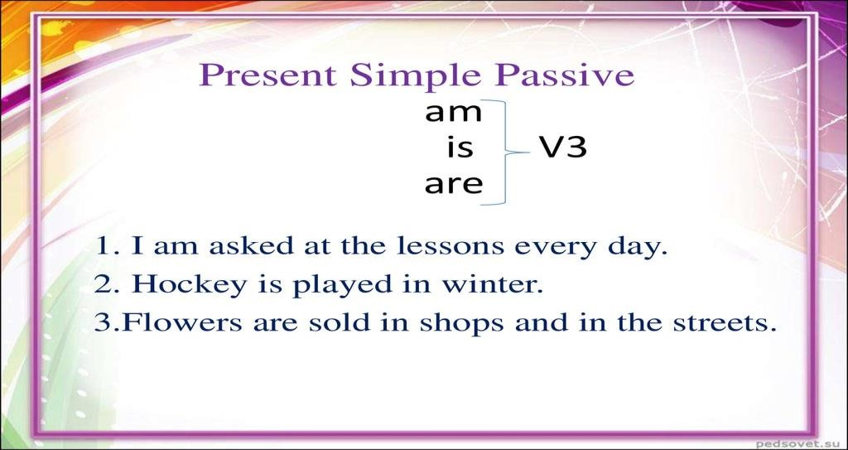
Passive Voice – Страдательный залог Present / Past / Future Simple

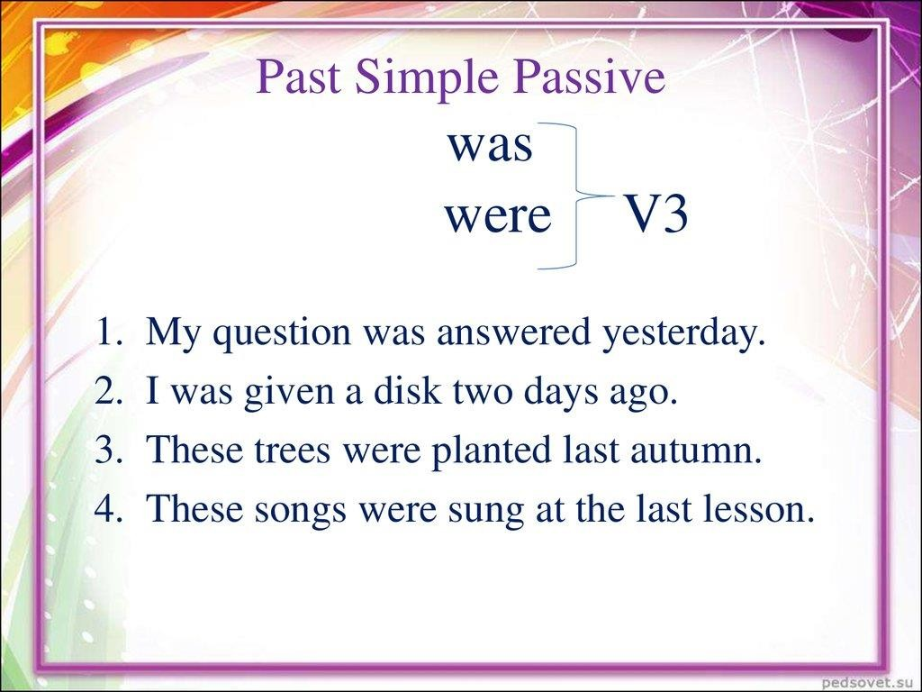

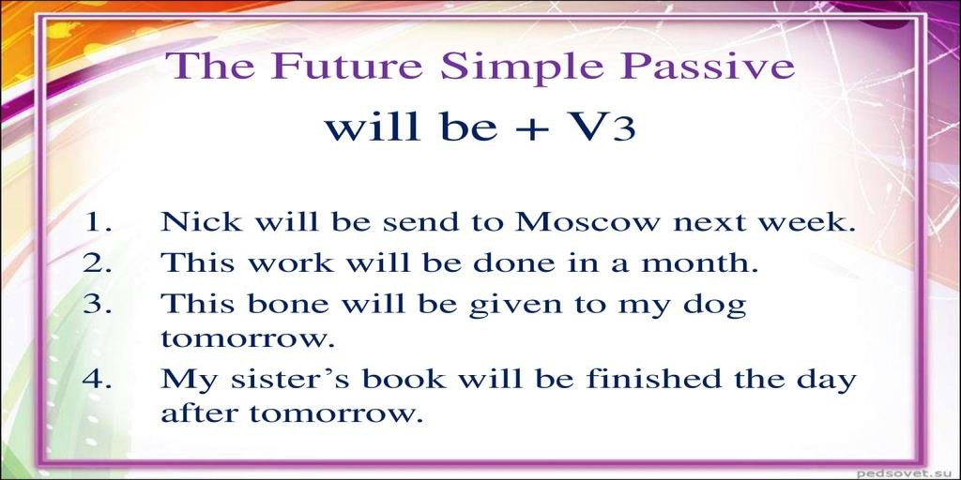

Examples:

- Linda could see diagrams on the screen. They in DRAW
different colours which made them look complicated.
- He put on a sweater, jacket, gloves, boots and a hat, and opened his front
door. Everything with snow. A cold wind blew inside. COVER
- The cake with chocolates and jellies, and it had as many DECORATE
candles as the number of years Carlos had reached that day.
- “My car was absolutely new! It only a week ago.” BUY
- The pilot informed the passengers about the details of the flight.
Then we refreshing drinks. OFFER
- It took the girls half an hour to make a list of guests.
Each name carefully on glossy paper. WRITE
- One of them showed Tim and his mum round the shelter.
Lots of animals there. KEEP
- The test was really long – the tasks on both sides of the page! PRINT
- The sky with heavy dark clouds. But the weather didn’t COVER
didn’t make our parents change their plan.
- The poem on the board, our new teacher read it and then WRITE
we discussed the poet’s message, choice of words and other poetical things.
- Amazingly, many of the houses centuries ago! BUILD
- The company ‘Imagination’. They CALL
focused on Internet technologies.
- The guitar of wood, not plastic, and Dana liked the way MAKE
it sounded.
- As a result, now people to walk around the monument but ALLOW
they can’t come up very close to it.

- Today Facebook by over a billion people. USE

Предложения с I wish в английском языке
Время глагола | Значение | Пример | Перевод
 | Сожаление о |  | Мне жаль, что ты не
 | невыполненных |  | учишь английский
 | действиях, не |  | язык. /Хотел бы я,
I wish + Past Simple | произошедших событиях | I wish you studied | чтобы ты учил
 | в настоящем (редко в | the English | английский (но ты
 | будущем) времени. | language. | не учишь).
 |  | I wish I knew the answer. | Хотел бы  я знать ответ (но не знаю). / Жаль, что
 |  |  | я не знаю ответа на
 |  |  | это.
 | Сожаление о давно | I wished I had | Я сожалел, что я не
 | совершенных действиях, | known it before. | знал этого раньше.
 | прошедших событиях. |  | /Мне было жаль,
I wish + | Сожаление к тому, что |  | я хотел бы знатьэто
Past Perfect | получилось именно так, а |  | раньше (но не знал).
 | не иначе.
 |  | She wishes she had | Хотела
 |  | worked on that day. | бы она работать в
 |  |  | тот день (но она не
 |  |  | работала)./ Ей жаль,
 |  |  | что она не
 |  |  | работала в тот день.
I wish would  +инфинитив | Негативное отношение к каким-либо действиям, событиям; желание  изменить их в будущем. НЕ | I wish you would stop writing to me! | Когда же  ты прекратишь  писать мне! / Жаль, что ты не
 | сожаление, а недовольство, |  | прекращаешь
 | неприятие, раздраженность. |  | писать мне.

Examples:
  - “I wish people about the environment more.” CARE
  - Liz thought, “I wish I cancel the party but I can’t – it’s too late.” CAN
  - "I wish the weather more cheerful!" said Edmund. BE
  - “I wish I my work as much as you enjoy yours,” ENJOY
  - ”I wish all children reading so much,” the librarian said. LIKE
  - I wish I as much free time now. HAVE
  - “I wish I who he was.” KNOW
  - “I wish we a class for girls only,” Tina thought. HAVE
  - I wish all people foreign languages. SPEAK
  - “I wish you more time with your classmates.” SPEND
  - "I wish Roxy some tricks”, Robbie thought. KNOW
  - “I wish I a pair of woolen socks. But I left them at home.” HAVE
  - “I wish I what is going on,” Steven said to himself KNOW

Условные предложения в английском языке
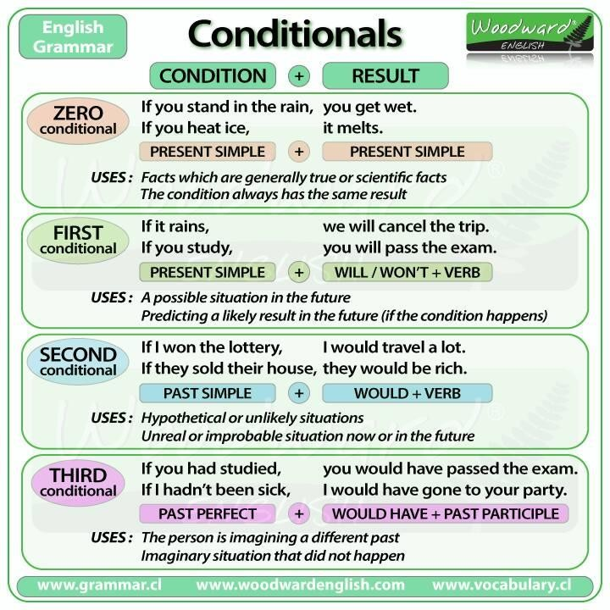

Examples:
- “If the box was mine, I _ you to touch it whenever ALLOW
you wanted,” I answered.
- “If it goes on like this, mum us a great dinner,” he said. COOK
- “No, I don’t. I wouldn’t ask you if I .” KNOW
- “If I don’t invent a very good excuse, she my parents.” CALL
- “But if there no computers, I wouldn’t be able to BE
communicate with my friends who live far away from me,” Michael replied.
- “If you are late again, you your job.” LOSE
Martin was afraid of losing his job.
- “If you go on like this, you a chance to take part in HAVE
the Dance Competition next month.”
- If we didn’t have robots, our life less comfortable and BE
more dangerous.
- “And what will we do if it ?” my brother asked quietly. RAIN
- “Ok. I you the bear if you want”, said Dad. BRING

Придаточные предложения времени
Отвечают на вопросы: when? когда? since when? с каких пор? how long? как долго? Соединяются с главной частью союзами:

- when – когда,  - while – в то время как,  - as – когда, в то время как,  - after – после того как,  - before – до того как, | - till, untill – пока, до тех пор пока,  - as soon as – как только,  - и др.

Примечание: в придаточных предложениях времени НЕ употребляется будущее время, вместо него используется настоящее. Важно это учесть, т.к. в русском языке в аналогичных конструкциях употребляется будущее время.

I’ll call you back when I return. | Я перезвоню тебе, когда вернусь.
When I meet my colleague, I’ll tell him  about this story. | Когда я встречу своего коллегу, я  расскажу ему об этой истории
After the rain stops, they’ll go to the  supermarket. | После того, как дождь кончится, они  пойдут в супермаркет.

Examples:
  - "Let me think about it. I you a call when I decide GIVE
what to do." But Dylan had already decided what to do.
  - “Ok-ok, just a second,” laughed Jeff picking up another doughnut and
retreating through the other door. “I as soon as I am ready.” COME
  - “When the walls in those colours, PAINT
the room will look cheerful.”

  - “Mum will be surprised when she the news.” LEARN

Согласование времён в английском языке Прошедшее согласование
В предложениях с прошедшим временем глаголов в главных частях придаточные тоже требуют прошедших времён.
Если действие дополнительного придаточного предложения:
    - одновременно с действием главного, то глагол придаточного предложения стоит в Past Simple (при переводе такого предложения на русский язык глагол употребляется в настоящем времени ):
      - I thought that he went to school. Я думал, что он ходит в школу.
      - She said that she liked History. Она сказала, что она любит историю.
      - He knew that she was cheerful. Он знал, что она веселая.

    - предшествует действию главного, то глагол придаточного предложения употребляется в
Past Perfect ( при переводе на русский язык глагол употребляется в прошедшем времени)
      - He said that he had seen that film. Он сказал, что видел этот фильм.
      - He thought he had signed the document Он думал, что подписал документ

    - следует за действием главного, то глагол придаточного предложения употребляется в
Future-in-the-Past ( в русском языке соответствует будущему времени)
      - She knew that I would help her. Она знала, что я помогу ей.
Examples:
- Inside the second package were glow-in-the-dark pyjamas! Judy said she
to try them on immediately. WANT
- Tim told his mother that he to go to the shelter again, WANT
not only to watch but also to help the volunteers.
- I asked my new friends what they usually for entertainment DO
in such a cold climate.
- One of my classmates said that the tradition him to HELP
pass his exams last summer.
- Hugo understood that he her many times in different TV programmes. SEE
- When we got there, we discovered that we to take FORGET
the fishing rods.
- Steven was upset but he hoped that one day he Eliza again. SEE
- He also said that she creative and had imagination and that BE
was why she had a good chance of succeeding in the job.
- She believed that it her keep fit and gave her extra energy. HELP
- But his mother said that they out of the water till the sea STAY
calmed down.

Грамматические правила, которые иногда встречаются в заданиях: - Gerund ( Герундий)

- Tag questions (Разделительные вопросы)
-Question to the subject (Вопрос к подлежащему)

- Глаголы, после которых употребляется только герундий:

hate (ненавидеть), enjoy (получать удовольствие) , deny (отрицать) and etc.

  - can’t stand — не могу терпеть
I can’t stand his smoking in the room. — Я не могу терпеть, когда он курит в комнате.
  - to be worth — стоить чего-либо
This place is worth visiting. — Это место стоит посетить.
  - it’s no use — бесполезно
It’s no use trying to escape. — Бесполезно пытаться сбежать.

Example:
The boys spent most of the day wandering around Times Square. They
enjoyed all the people and the street performers. WATCH

*****************************************************************

Вопрос к подлежащему:
Вопрос к подлежащему можно задать при помощи слов:
- Who? (когда речь идет о живых существах)
- What? (для неживых, например, к вещам, растениям, природе и пр)
Нет необходимости менять порядок слов в предложении и не нужно добавлять вспомогательные глаголы — do/does, did и пр. Это означает, что английское предложение должно быть построено так, будто на месте who/what стоит he/she.

Who lives in London?  Who is reading the book now? Who has a dog?  Who played football yesterday? | What is there on the table?  What appears in the sky every day? What happened?

Examples:
- “You are late again, Paul. What _?” HAPPEN
- “Are there any crocodiles? Who care of the lions?” TAKE
- “Who a pie?” her mother asked. “I can smell it. MAKE
How soon is it going to be ready? I’m very hungry.”

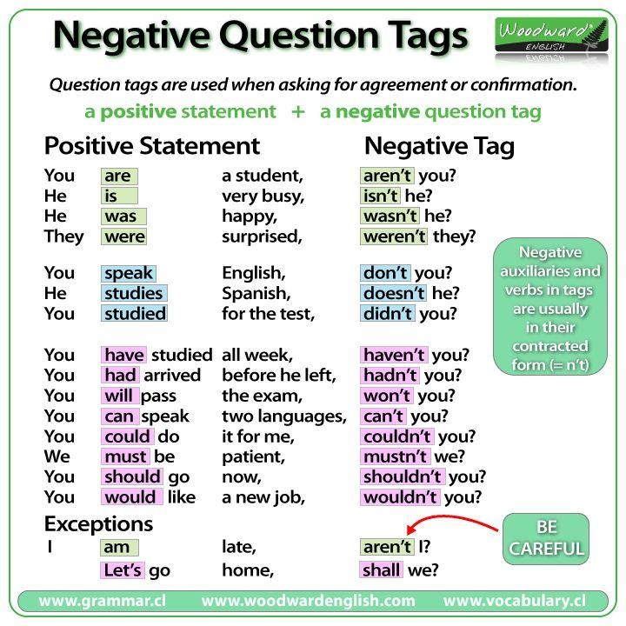
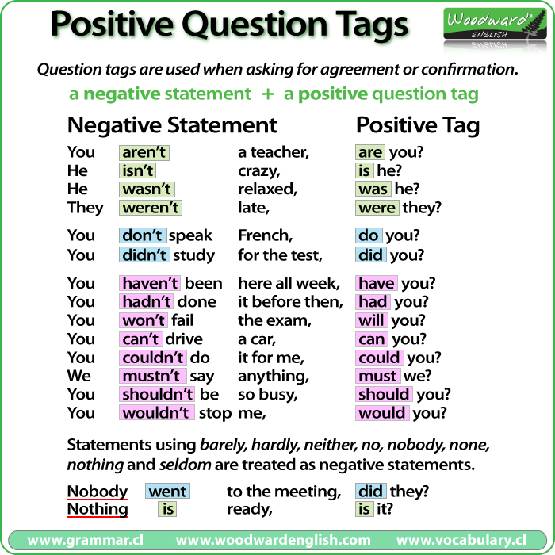

Example:
- “We should start with the list of guests and with the programme for the event.
You who you want to invite to your party, haven’t you?” DECIDE
“No,” answered Mary, “I haven’t.”
- Grandma something nice for me, hasn’t she?” COOK
- “Oh, it’s ok,” said Kate, “Come in! You me in the kitchen, HELP won’t you?”

Practice:
- It was about 6pm when I heard a knock on the door. It Jason, BE
my teenage neighbour. He looked cold and upset. “What’s wrong, Jason?”
“I _ my key and I can’t get into my house.” LOSE
“Come in. Today’s not a day for long walks, or long waits,”
I looked out the window. It hard and it was windy. SNOW
The weather was getting every hour. BAD
Jason off his coat and boots. TAKE His were wet and I gave him a pair of socks to change into. FOOT A cup of hot tea and some biscuits soon made the boy feel warm.
“Where are your parents, Jason?”
“I . NOT/KNOW
I can’t call them because of this,” he pulled his phone out of his pocket and
showed it to me – the screen and the phone was BREAK

obviously dead. Jason focused on the food again. He took his biscuit and said: “I wish my mum could make biscuits like this.”

FOUR

- By today’s standards, my mobile phone is pretty basic. It’s a Nokia. It’s a small device that receives telephone calls and sends text messages.
Other than that, my phone much. Most of my NOT/DO friends wish they smartphones because they are cool HAVE and trendy. They say the thing about a smartphone is that you GOOD ‘can do everything with it!’ That’s right, smartphones have many more
functions than a simple phone, however, not all of them are needed. In
everyday life, smartphones mainly for checking USE
social networking sites, replying to emails, and playing games. Grown-ups as
well as like playing games. Anyway, I prefer my good CHILD
old Nokia. It’s my mobile phone. When I bought ONE it, it didn’t cost very much. And I am not afraid anyone will I ever steal it. It’s also very reliable. Yesterday I dropped it. It _ FLY down the staircase and hit the wall. I thought that the end of it. BE But nothing of the kind – it still works properly!
- Kate called me early in the morning. It was the _ day of TWO
holidays; I felt angry with her for waking me up.
“What ?” I didn’t sound very polite, but she paid no HAPPEN
attention to that.
“Oh, nothing! I want to go shopping today and wondered if you wanted to
go with .” I
“No, I don’t want to.”
“But it you long! I promise”. NOT/TAKE My first impulse was to say “no” – unlike most I hated WOMAN shopping. But Kate sounded so unhappy that I felt sorry for her.
“Ok, what do you need to buy?”
Kate’s voice cheerful again. She excitedly explained BECOME to me that she to buy a pair of hiking boots and a raincoat. WANT That strange as Kate had never been fond of hiking. BE
“I want to take up hiking as a new hobby,” went on Kate. “Bob Smith says that it’s very exciting.”
Now I knew what was going on. Bob Smith, the captain of the school
baseball team, was the boy in our school. All the POPULAR
girls wanted to attract his attention.

- Emma lived in a big city and worked for a large company. Her days
were usually very busy – she hardly find half an hour for lunch. CAN However, at weekends she bored and lonely. Emma had FEEL moved to the city because of her job. Only two months before she had
thought she was the girl in the world. She had got a job LUCKY most of her friends could only dream about. It was her _ _ ONE full-time job. The company ‘Imagination’. They CALL
focused on Internet technologies. Emma much about NOT/KNOW
the Internet but her boss said that it didn’t matter.
He also said that she creative and had imagination and that BE
was why she had a good chance of succeeding in the job. When Emma told her friend, Lucy Pitt, about the new job, Lucy said: “I’m very happy that you
a good job. But I also feel very sad about it because FIND
you’ll go to the city and will forget about your friends.”
“I wish we could always be together but it’s impossible,” Emma said.
“I promise that I to visit you as soon as I can.” COME

- It was a cold January day in York, Pennsylvania. Dr. James turned on the television to check on the weather. The weatherman said that it was going to
stay cold for several days. According to him, the roads BE
very dangerous because of the snow and ice and he strongly recommended
staying at home if at all possible. Dr. James stay at NOT/CAN
home. He worked in a hospital and there were patients waiting for him there.
He put on a sweater, jacket, gloves, boots and a hat, and opened his front
door. Everything with snow. A cold wind blew inside. COVER

“Wow,” Dr. James said. “The weatherman was right! I wish I
a reindeer instead of my old car.”

HAVE

When Dr. James slowly to work, he saw an accident. DRIVE He stopped and to the damaged car. There was a man RUN and two inside. CHILD
“Is everyone okay?” Dr. James asked.
“Yes, yes, we are fine,” answered the man. “I 911 already. CALL They are coming to help . It looks like we won’t get to WE school today.”

- Jane liked going to the park with her mum. One day when they were there, she said, “There is so much rubbish on the ground.”
They looked around. There were old , waste paper and BOX cans on the ground. Several benches . BREAK “You are right,” her mum said. “I wish people about CARE the environment more.”
“I do care about it but I _ what I can do to help the park,” NOT/KNOW
said Jane. Jane and her mum went home. In the evening she painted a picture

of the park. At the top of the picture she “PLEASE KEEP ME CLEAN”.

WRITE

The next day Jane and her mum went to the park than usual. EARLY
Jane taped her picture onto a big rubbish bin and started picking up rubbish. Some children ran over to see what was going on. They decided to help Jane. Soon all the rubbish was in the bags.
“Good job,” Jane said, “We half of the park. If we come CLEAN
and complete the other part tomorrow, the whole park BE
clean and tidy.”

- Dana Miller was a bus driver in the city of Philadelphia. Her working
hours from 10.00 pm till 6.00 am. It was a hard job and very BE few worked as bus drivers in those days but Dana loved WOMAN her job very much. One of her regular passengers was a guitar player.
Every Friday night he got on the bus carrying his guitar. The guitar
of wood, not plastic, and Dana liked the way it sounded. MAKE
“You should come to see our show,” the guitarist kept saying to Dana.
“I it one day,” Dana promised each time, but she never SEE said when exactly she . Another passenger who often GO used Dana’s bus was a Biscuit Lady. She worked at the biscuit factory and
often Dana a small bag of biscuits. GIVE Dana sweets and pastries very much, but she could never NOT/LIKE resist those biscuits – they were so fresh and tasty.
“How was night?” Dana’s husband liked to ask her when YOU
she came home.
“Good music, good food and a great view of the city,” she cheerfully
answered. “I wish I my work as much as you enjoy yours,” her ENJOY
husband said,“ but I’m going to have just another boring day at the office.”

- After school, I decided to go to university. I St Andrews University in Scotland. At that time I much about the University but when I arrived there, I liked it at once. Now

CHOOSE NOT/KNOW

I'm in my last year and I wish I stay here forever! CAN

St Andrews University is a truly special place. It _ 600 years ago and it is one of the oldest universities in the English-speaking world. It has many traditions – for example, the ‘May Dip’. It is held on

BUILD

the of May every year. All the students run into the ONE
North Sea at sunrise to celebrate the coming of spring and for good luck!
One of my classmates said that the tradition him to HELP
pass his exams last summer.
For me the ‘May Dip’ was the experience of my life! COLD
Because the weather is famously cold, St Andrews students designed
own uniform which consists of a warm jacket, jeans and THEY boat shoes. The uniform us all look the same, but it MAKE is the only way to keep warm!

- Mr. and Mrs. Wormwood were our neighbours. They had two
. CHILD
Their son Michael from the other children very much, NOT/DIFFER
but their daughter Matilda was a brilliant child.
By the time she was five, Matilda was able to read very well. She studied
every magazine and newspaper that she find around CAN the house. Actually, she read _ than most school pupils. WELL One afternoon when the parents were out of the house, Matilda put on
dress and shoes and went to the library. SHE
The librarian was surprised to see such a small child. "Are you here for the
time? Would you like me to find a nice book with lots ONE
of pictures for you?" she asked.
"No, thank you, I what I need," answered Matilda FIND showing a thick book of fairy tales. Then she added, “I _ COME for a new book as soon as I finish this one”.

- It was an early morning. Ben jumped out of his bed as soon as the
rays of sun came into the room. He grabbed his backpack ONE
and started to pack. Ben put in some of his favourite things to take with
on the trip to Grandpa’s. He put in his favourite book, HE his kite and his teddy bear. Soon everything and PACK he started to get dressed. Visiting Grandpa had always been the _ GOOD part of his summer vacation. Together, they went fishing and watched
football matches. Ben’s granddad him how to repair TEACH
bikes and other things. Ben’s mum entered his room. “Grandpa’s here,” she
said with a smile. Ben told her that he ready to go. He grabbed BE

his backpack and ran into the kitchen where Grandpa his tea.
“Ready, big guy?” asked Grandpa. “Will you have breakfast before we leave?”

DRINK

“No, I hungry”, Ben answered, “I’ll have breakfast at your NOT/BE
place. Grandma something nice for me, hasn’t she?” COOK

- When you look at this lovely house in the Welsh countryside, you may think it's a picture from J.R.R. Tolkien's book ‘The Hobbit’. In fact it's a real

house designed by a real person. When Simon Dale’s wife, Jasmine, said:
first son was born, THEY

“I wish we in the country. It would be so good for the baby”. LIVE However, they enough money to buy or rent a house NOT/HAVE in the country so they decided to take matters into their own hands.
The house by Simon himself, with a bit of help from BUILD
his friends. The result is impressive. The home is made of natural materials, such as wood, stone and mud. It uses solar panels for energy and its water
from a nearby spring. COME
It took Simon four months to complete his fairytale home. He managed to

create a modern wooden eco-home – one of the _ houses you can imagine.

WONDERFUL

Simon Dale said, “I working on a new house of the START same eco-style. My house will be smarter than the first one. TWO My son five now and I hope to celebrate his tenth birthday in BE
a new house.”
- Harry’s class was going on an excursion to the firehouse. Harry
proud because his Uncle Jim, a fireman, was going FEEL
to show the children around the place. Naturally, the first thing Harry’s
classmates wanted to see was the huge fire truck. There _ BE
eight vehicles at the firehouse at that moment. Uncle Jim explained how the trucks got water and even let the kids get inside the truck.
“Have you ever fought a fire ?” a red-haired boy asked. YOU
“Yes, many times, unfortunately,” Uncle Jim answered. “I wish people
more responsibly when they used electrical devices at BEHAVE
home or had picnics outdoors. But they often NOT/THINK
anything can happen to them. Please remember that you _ NOT/MUST make fires in the woods. There is dry grass and dry _ LEAF on the ground. They start to burn very easily. And there is nothing
than forest fires!” DANGEROUS
The children promised not to make any fires in the woods and Uncle Jim
went on with the tour. He them the fire alarm equipment, SHOW
when a siren started wailing.

- It was a great day yesterday. My friends and I __ to see GO
a performance at the Bolshoi Theatre. You certainly know that the Bolshoi
Theatre is the theatre in Russia and probably in the world. FAMOUS But not everyone the history of the Bolshoi Theatre. KNOW According to historical documents, it in March 1776 when BEGIN Prince Pyotr Urusov was granted Royal permission to build a public theatre
in Moscow. Catherine II, Empress of Russia, was fond of arts. She
having a new theatre in her country. The original NOT/MIND
building of the theatre had a hall with almost 1,000 seats, a stage and an
orchestra pit. Directly over the stage there boxes where the most BE
noble fans of the theatre had their seats. The theatre has changed several
times during history. The building we can see today opened IT in 1825. It by architect Andrei Mikhailov who was also DESIGN the architect of the Maly Theatre.
Since that time, the building has been rebuilt and renovated several times.

Now it looks beautiful from the inside and outside. If I the opportunity to go there more often, I would do it every week.Judy was afraid of the dark. At night she always _ the lights on. Judy couldn’t explain what exactly she was afraid of. She

HAVE

LEAVE

in monsters or in ghosts. She was one of those NOT/BELIEVE

rare girls who never screamed when she saw spiders, and frogs. But everyone in her family knew that a dark room was the

MOUSE

of her fears. BAD
One day, when Judy something in her room, her DRAW
mother came in holding a big shopping bag.
“Guess what I ,” she said to Judy. BUY “I have no idea. Is it for ?” Judy felt very curious about the bag. I Her mother pulled two packages from her shopping bag. In the first package
there were some very nice slippers. They from soft, MAKE
pink fabric and had bright flashing lights. Inside the second package were
glow-in-the-dark pyjamas! Judy said she to try them WANT
on immediately. Amazingly, she felt safe all through the night. In a few days the lights stopped flashing but Judy realised she didn’t feel afraid of the dark any more.
- Mary’s birthday was on Saturday and she decided to arrange the party
all by herself. At first, making a party to celebrate her _ FIFTEEN
birthday looked like an easy thing to do. But when Mary started planning the event, a lot of questions came up. And the main problem was that she
what to start with! Mary called her cousin Vicki and NOT/KNOW asked if she help with the arrangements. CAN Vicki was a year and more experienced in arranging parties. OLD Vicki agreed and went to Mary’s house at once. When Vicki arrived, Mary
a menu for the party. Vicki looked at the draft of DESIGN the menu and Mary that her approach was totally wrong. TELL “We shouldn’t start with the menu,” she said, “We should start with the

list of guests and with the programme for the event. You who you want to invite to your party, haven’t you?”
“No,” answered Mary, “I haven’t.”
It took the girls half an hour to make a list of guests.
DECIDE

Each name carefully on glossy paper. WRITE “It looks fine,” said Vicki, “But there are too many of . Don’t THEY you think so?”

- Tom woke up relatively early. But he at once UNDERSTAND
that he was not the first awake. There was somebody in the kitchen already. Tom went out to inspect, and found that his dad was there – he
vegetables. It was rather strange – everyone knew that CUT
dad cooking. NOT/LIKE
“I wish I what you are doing,” he said. KNOW Dad gave a smile and answered “Wait and see.” HE He pulled out a juicing machine from the cupboard. Nobody had used it for
ages and the machine with a thin layer of dust. Tom’s COVER
dad washed it and turned it on. Then he put a handful of carrots inside.Next
he added cucumbers and . Dad made three large cups TOMATO

of the stuff. He took one and drank it. He handed the cup to Tom. To his surprise the juice tasted really good.
“You don’t eat enough vegetables,” his dad said. “If you don’t like eating them, you’ll probably like drinking them.” Tom nodded. It was definitely
TWO

than the stewed vegetables his mum cooked almost GOOD
every day.
- It was the middle of November and Tina felt down and depressed. Late
autumn was the season of the year. BAD It often , and Tina had to spend most of her time indoors. RAIN Because of this, she really welcomed the changes in her school routine. The
school administration introduced a new class - a dance class. But not
everyone was happy! The boys said that it a waste of time. BE They often missed the class and, when they attended, they _ NOT/LISTEN to the teacher’s instructions but tried to make fun of everything.
“I wish we a class for girls only,” Tina thought. HAVE

The Junior Dance Competition every year. It was a spectacular show.
in their town HOLD

“Your dancing every day,” the teacher said one day. IMPROVE “If you go on like this, you a chance to take part in HAVE the Dance Competition next month.”
Tina imagined herself wearing a beautiful dress and elegant shoes on her
. She decided it was something she’d like to try. FOOT
- Tim liked going to the zoo. One day his mother said:
“We’re going to a different place today, Tim. It’s an animal shelter. I’m sure
you it.” LIKE
The place was much than a zoo, but clean and well kept. SMALL

There were volunteers in special uniforms. One of them showed Tim and his
mum round the shelter. Lots of animals there. KEEP

Cats and dogs made up most of the population, but there were also horses,
monkeys, and other animals. Each of the animals had FOX
its own story written on a sign next to its cage or enclosure. All the stories
were sad – the animals had either been abandoned by _ THEY
owners or saved by the animal police from cruel treatment.
‘If people more responsible for their pets, we wouldn’t BE
have so much work here,” the volunteer remarked.
“But unfortunately some people that animals are NOT/UNDERSTAND
not toys.”
Tim’s mother thanked the volunteer and a donation. MAKE
Shelters always needed money to pay for the animals’ food and medical

care. On the way home Tim told his mother that he to go to the shelter again, not only to watch but also to help the volunteers.

WANT

- Kathy looked at her new room’s white walls. “They’re so plain.”
“Don’t worry,” Dad said, “If you don’t like them, we
the walls any colour you like.”

MAKE

“Do you want pink?” Mum suggested. Kathy her head. SHAKE “No, pink is either for or for silly girls who like Barbie BABY dolls. I’m neither of those.”
Her parents smiled but anything. NOT/SAY “But what colour to choose? I wish we ask a designer for CAN professional advice,” said Kathy.
“Oh, no! It’s out of the question!”said Kathy’s mother firmly.
“A designer’s advice is much than we can afford.” EXPENSIVE
“Ok. It was just an idea.”
“Getting back to the wall colour, why not make your room yellow or orange?”
Dad suggested. “When the walls in those colours, PAINT
the room will look cheerful.”
“Yes!” Kathy definitely liked the idea. “We’ll make three walls yellow, but
the one will be orange.” FOUR
The next day, when Kathy came back from school, her Dad said:
“Look what I .” There were paints and brushes on the floor. BUY
“Everything’s ready for us to start.” He smiled and handed Kathy the brush.Veronica loved autumn. It was her favourite season. There were many
good things about it. She loved the smells, the changing _, LEAF
and the cool breezes.
There also apple pies, apple doughnuts and pumpkin pies. BE For Veronica, pumpkin pies were the , especially when GOOD her mother cooked them. Veronica had never tried to make a pie , SHE but she knew how, as she had seen how her mother made it many times. One
day, on her way from school, Veronica a pumpkin and BUY
decided to cook it. She tried to do everything the same way her mother
usually did. Veronica was in the kitchen and the NOT/HEAR
door bell. Her mother had to use her key to enter the house.
“Who a pie?” her mother asked. “I can smell it. MAKE
How soon is it going to be ready? I’m very hungry.”
When the pie was ready, Veronica put it on the table. The pie looked nice:
it with nuts and coloured sugar. Veronica’s mother DECORATE
had a large piece. She smiled and said that she it very much. LIKE

- Bella was a good student. She learning but she ENJOY
always started to feel very nervous when she had to write tests.
That Monday a lucky day for her and she realised it as NOT/BE
soon as she came into the classroom.
“Oh, no! I all my pens at home.” She turned to Jenny: LEAVE
“Have you got a spare pen?”
“Let see,” Jenny opened her bag and pulled out a pen. I
“I’ve got this one. But it’s green.”
“Give it to me anyway,” Bella said. “If I don’t find a proper pen, I
in green ink. I hope it won’t affect my grades.” WRITE

When the teacher handed out the tests, Bella felt even than she had felt before. The test was really long – the tasks

BAD PRINT

on both sides of the page!Bella did the first task quickly, but the _ TWO
one was a real problem. Bella got panicky. Time ticked on but she
concentrate on the tasks. NOT/CAN

- It was a hot summer day. Tom and his mum were heading to the beach. Tom was only wearing shorts and a pair of sandals on his but he felt hot anyway. When they came to the beach, they found out that

FOOT

the sea calm – powerful waves were breaking on the shore. NOT/BE Mum in hesitation. STOP “It’s fine. I can easily swim in these waves,” Tom wanted to demonstrate
his swimming skills. But his mother said that they out of STAY
the water till the sea calmed down. Sitting close to was a boy THEY

about Tom’s age. He was alone because his parents to buy some sandwiches. He came over and said his name was Gary. His

LEAVE

shoulders with protective suntan lotion, but they COVER
looked red anyway.
“It’s getting every minute,” said Gary. “How about a swim?” HOT
“No way,” Tom’s mother was definitely against the idea and Tom had to obey. “As you like,” Gary said and headed for the water.
The wave hit him hard and he lost his balance. Everything THREE
was happening very fast – Gary fell down and went under the water. Fortunately, Tom and his mother were close enough to get him out in time.

- Cindy liked parks. She took long walks in the nearby park almost every
day. Her classmates, however, her interest NOT/SHARE
and Cindy usually walked alone. Cindy’s parents worried that she
no friends. HAVE
“I wish you more time with your classmates. Don’t you SPEND
feel bored in the park?”
“It’s ok, Mum, I just feel much alone than with people GOOD
who can’t understand me,” Cindy usually answered. “Parks are a lot more fun to spend time in than hanging out in a shopping centre.”
And her mother didn’t know what to say.
One day, Cindy returned from the park very excited.
“Guess, who I met in the park!” she said, and she told her parents the whole
story. “I along the central avenue when I saw a WALK group of people. They _ students of the Biology faculty of BE the university. They told about the plan to rearrange the park. I
A large lake is going to be made in the centre. There will be wild animals
there like hares, squirrels and even . Yesterday, FOX
the plan by the City Council and work starts APPROVE
tomorrow. I want to join the volunteer team!”
- The camel was very thirsty. His last drink had been weeks ago. His
feet sank in the hot sand and he hardly move. CAN "When will I reach water?" he thought. "And I for ages." NOT/EAT It was obvious that if the camel didn’t find any water and food soon, he
. He made a few steps toward another dune. It was DIE
to walk along the top of a hill, than along the bottom. EASY
At last he something green in the distance. Was it SEE
a mirage or an oasis? He hoped for the best and the hope helped HE
move faster. Soon, that distant green colour turned into real trees and grass.
There a small stream of water and some palm trees that gave BE shade. Their wide could protect the camel from the sun's rays. LEAF Though the sun , it didn’t burn anymore. Unfortunately, SHINE it was impossible to stay there forever. A short rest and the camel had to
move on towards his destination.

- Susan’s father often had to go to different countries on business. That
evening, he came home _ than usual. He looked tired. LATE Susan that the next week her father was going to China KNOW to discuss a new project.
At dinner, her father asked Susan if she to go with him. WANT
It was a bit unexpected but Susan liked the idea at once.
It was her birthday in a few days. And Susan thought SIXTEEN it fun to celebrate it abroad. However, there was one BE thing she wanted to clear up before the trip: “Are you going to be busy from
morning till night? I to sit in the hotel all the time alone.” NOT/WANT

“You won’t have to,” her father reassured Susan. “I all the project papers already. So, while our partners are studying them, we’ll have plenty of time for sightseeing.”
“Great!” Susan ran up to her room to pack.
PREPARE

“Remember to take some comfortable shoes. Otherwise your _ FOOT
will hurt after the long excursions.” Her father’s advice was always
practical. Half an hour later everything in PACK
a suitcase and Susan called her best friend to tell her the news.
- As a child, Steven lived in a village. Outside the village there was a house where a strange old woman and her granddaughter Eliza lived. The
often played together. CHILD
One day, Eliza unusually sad. When Steven was about BE
to leave, the old woman said, “I know you are friends. But never come to our house again. Never ever!”
The girl took the boy to the gate. “Will you miss me?” she asked.
The boy said, “Yes, I will!” To his surprise, the girl said, “But I won’t!
I to see you anymore!” She closed the gate. NOT/WANT
The next day the girl for the city. Steven was upset LEAVE but he hoped that one day he _ Eliza again. Five years SEE later Steven became a student and moved to the city. He rented a small
apartment on the floor. ONE One day, when he to the university, he saw Eliza. WALK She was sitting on the bench in the park with an ice-cream in her hand. He
ran up to her and said “Hello! It’s nice to see you again!” But Eliza looked
up at , stood up and walked away. HE
“I wish I what is going on,” Steven said to himself, KNOW
and decided to start his own investigation.
- I remember my uncle Thomas very well. My mum says I can’t because I was a little girl, only three at the time. But my memories of him are still very vivid. Uncle Thomas was a sailor. When he returned from his
last trip, he brought several large with him. Inside there BOX
bits of wood, metal, and painted cloth. “What is it for?” BE
I asked my uncle. He _ me a broad smile and said: GIVE

“Have your breakfast first and then come to the backyard. You
everything with your own eyes.”
SEE

When I came to the backyard, Uncle Thomas an READ
instruction manual. It took all his attention because the manual
in Spanish, a language my uncle didn’t know very WRITE well. All in all, it took a couple of weeks to assemble the HE object from the parts. To all my questions he said that it was a machine that
fly like a bird. I was probably the only one in the family CAN
who took his words seriously. They could never believe that soon we were
going to see one of the _ airplane flights in the country. ONE

- Robbie's dog Roxy was smart. At least Robbie so. THINK
Robbie had found him on a street. The puppy looked cold and unhappy.
Robbie took the puppy home and fortunately his mum it. NOT/MIND
One day Robbie saw the ‘Dogs' contest’ advert. According to it, all dogs that were able to perform tricks could participate.
"I wish Roxy some tricks”, Robbie thought. “But Roxy KNOW
can’t perform any.”
He decided to take Roxy to the contest anyway, not as a participant but as a
viewer. When they arrived there lots dogs on the contest ground. BE
The collars of some dogs with medals. DECORATE
The contest started, and the judge threw a ball. Roxy suddenly pulled away
from Robbie and began running fast. He was the _ dog ONE
to catch the ball and he didn’t forget to bring it back to the judge!
“The winner is the dog with no entry name on my list. Whose dog is this?” asked the judge.
“It’s dog." said Robbie. The judge handed Robbie a small I
symbolic medal and a certificate for free dog food.
“Congratulations! You_ !” said Robbie to Roxy and WIN
gave him a big hug. “Let’s go home and celebrate. Mum will be surprised
when she the news.” LEARN

- TIME is a weekly magazine published in New York. In 2010 the
magazine Facebook founder Mark Zuckerberg as CHOOSE
Person of the Year. Everything began in February 2004, when Zuckerberg was still a student at Harvard. He made an online platform to connect
college students. It helped to learn and socialise. Soon, THEY other joined Facebook and then it became popular UNIVERSITY with a much wider audience. Today Facebook by USE over a billion people. They play games, find friends, learn the news, and
share photos there. Not everyone, however, Facebook THINK is a good thing. My friend, Nicky, believes that I spend GOOD too much time online, on social networks.
“I wish you more time with your real friends,” he keeps saying. SPEND
Last Saturday when Nicky came to my place to discuss a school problem, I
online. He waited for a while but then left without CHAT

saying a word. And he _ since then. I feel I’ll probably NOT/CALL

have to change my habits if I want to have real friends, not only virtual ones.
- In 2010, a terrible earthquake hit the Haitian city of Léogâne. It was the
of January, my birthday. It was a normal day in the morning. TWELVE
I for my party when the earthquake hit. My first PREPARE
thought was that everybody was going to die. I NOT/UNDERSTAND
what was happening. It was the day of my life so far – BAD
I have never felt that scared! After the earthquake I asked my wife: "How are we going to go on living?"
"I have no idea", she said. "But we're lucky. Our house is still standing, and
thousands of people lost everything, even their ". LIFE
She was right. We had to help the others, so we decided to start a charitable
fund. At first we it the name of ‘Hope’ but then changed it. GIVE Now our fund 'Seeds for Change'. We work with CALL small farmers and provide people from rural areas with everything necessary
for farming. They say it helps them a lot. Their gratitude is the best award
for . If we manage to involve more people in our fund, WE
we _ more impressive results in the future. GET

- When I was little, I loved reading books written by Roald Dahl. They were my favourite choice of bedtime story.When Mum asked me what book
I wanted, I always a book by Dahl. Mum readily agreed. CHOOSE She said she reading him too in spite of the fact that ENJOY she was an adult and had a very serious job. In those years there _ BE lots of Dahl's books in our home library. And to me he is still the best
children's author of the _ century. TWENTY

Roald Dahl started as an adult writer. His first book in 1942. Later he began writing children's books. Many of the are based on Dahl's own childhood memories. Several of his books are now successful films, for example ‘Matilda’, ‘Charlie and the Chocolate Factory’
PUBLISH STORY

and ‘Fantastic Mr Fox’. I'm sure you at least one of them! SEE

When you shop for children's books, Dahl is the choice. His books are entertaining and full of jokes. Roald Dahl is an author that you can never grow tired of. Now I read his books to my son. He is too

EASY

small yet and cannot read . HE

- Martin and Jane were shopping. They were in the shopping centre in their city. In fact, it was their favourite place because it
LARGE

was nice and not very expensive. The centre Dress CALL for Less. Unlike most , Martin liked shopping. Today he MAN felt really happy because he a shirt and a pair of BUY jeans. Jane was still in the changing room so Martin had time for a cup of
coffee in the lobby. It was the first time Martin had had a good look at the
building itself. The shopping centre building impressive. BE
The engineers had used advanced technologies to make it light, warm and
spacious. “Hi!” Martin Jane’s voice. HEAR “What are you having? Coffee? No, I coffee. Never. NOT/DRINK It’s not good for your health. ”
“Look, Jane, do you know the name of the architect of this building?” Martin interrupted her. Jane looked puzzled.
“I wish we change our life a bit,” went on Martin. CAN
“We probably spend too much time on things like shopping and miss more important things. When was the last time we visited a museum?”
Jane quietly sat down on the chair beside . HE
- Dylan had a very old car. It was 20 years old. But the faded paint
made it look even than that. OLD It a shame to drive a car that looked like that and Dylan BE took it to a paint shop. There the car dark blue for $200. PAINT Dylan was very pleased with the new look. The only problem was that the
car stereo properly. Dylan managed to fix it himself. NOT/WORK
Then one day Dylan had a new problem – petrol. He could smell it while
he his car. Dylan asked himself “Am I driving a bomb? DRIVE
Could the car explode at any minute?”
He knew the car manual by heart. He had car problems at least once a
month, and he always found a way to fix himself. However, THEY
this time, it was a job for a mechanic. So he his car TAKE

to the closest service station. The mechanic said they the car to find out what the problem was. He told Dylan to come back in an hour. When Dylan came back, the mechanic said, "The problem is with the fuel pump. You need a new one. It costs $400."
TEST

"Let me think about it. I you a call when I decide GIVE
what to do." But Dylan had already decided what to do.

- Most people love jokes. A good joke can break the ice and make the conversation enjoyable. My friend’s hobby is collecting jokes. When he
a good joke, he writes it down on a special card. HEAR The cards in a box in his room. KEEP When I visit , I never miss a chance to read a joke from HE his collection. Yesterday’s joke was about famous detectives. Here it is.
One day Sherlock Holmes and Dr Watson went camping.They put up a tent,
made a fire and had a good dinner of meat and . POTATO That night, Holmes up and asked: "Watson, look up and WAKE tell me what you see." Watson said that he millions SEE of stars. "And what does it tell you?" Holmes went on his interrogation.
"Well, if we apply our deductive method, we’ll come to several conclusions.
Astronomically, there are billions of planets. My_ conclusion TWO
is astrological – I observe Saturn in Leo. And, meteorologically, it’ll be a
beautiful day tomorrow. I wish we this kind of weather HAVE
more often in this country. And what does the sky tell you, Holmes?"

Holmes was silent for a moment and then said, "Someone our tent!"
STEAL

- English, Welsh, Scottish…all these languages sound familiar. But I'm
sure you of Cornish. NOT/HEAR
I wish I it, like my Granny does. Cornish is a Celtic language, KNOW

used in Cornwall, a county in south-eastern England. ago, when the Anglo - Saxons invaded Britain, many Celts moved to the

CENTURY

mountain areas. Some Celts even the country completely LEAVE
and settled in France. Speakers of Cornish stayed in the south-west. There
the language until the late 1700s. But the number of SPEAK
speakers got smaller and the language almost disappeared. At the beginning
of the century, academics became interested in Cornish TWENTY
and started to study the ancient texts. From those old documents they managed to restore the language! Nowadays, if you visit Cornwall, you will hear a lot of it. The language is offered as an option in many universities,
and students choose to learn it. Like I did. I think it’s the THEY
language I have ever learnt, but it’s interesting DIFFICULT
and it sounds very nice. I believe the Cornish language __. SURVIVE

- Jenny loved climbing. It was a strange hobby for a girl and her family
wanted her to stop it, but Jenny to anybody. NOT/LISTEN
"There are still several trees in the garden I haven’t climbed yet," Jenny said.
One day, she the apple tree in the yard, when she suddenly CLIMB slipped and fell down. Jenny a terrible pain and started to FEEL cry. Her mum came outside and saw that her hand was swollen and looked
dark. "I wish you some other hobby!" she said. HAVE "Jenny, please, promise that you'll never do this silly climbing I again!" Jenny nodded. Her mother took Jenny to the doctor. It turned
out that two of the bones . BREAK For the time Jenny had a cast on her arm, from her fingers ONE down to her elbow. For several weeks, Jenny had to have the cast on. It was
a huge relief to get it off, finally. At last she could get back to her favourite
which were running, swimming, and climbing. ACTIVITY
But now climbing was out – Jenny was determined to stick to her promise.
“If I break my promise, mum upset. And I don’t want GET
her to feel like this.”

- A few days ago Kim’s family moved house. Kim had very mixed
feelings about it. On the one hand, she happy with her FEEL
new room. It was larger than the room she used to live in. Everything in this
room in Kim’s favourite colours and according to her ARRANGE taste. The flat was on the floor in an old brick building. FIVE From her window Kim could see the large garden, which now was covered
with bright yellow , and the tiled roofs at a distance. LEAF “I’d be very happy if I here,” Kim’s friend, Jessica, LIVE said when she visited her for the first time.
“And how is your new school?” she asked, still admiring the fresh
wallpapered walls with a few framed photos on . THEY “You new friends there, right?” MAKE These words made Kim feel nervous. “No, not yet.” she answered.
Then she said that she to her new school only the next GO
Monday and that the school looked nice and modern and there was a
swimming pool in it. What Kim her friend was that she was NOT/TELL
awfully afraid of going there and meeting her new classmates and teachers.

- A robot is a special kind of machine that follows the instructions
coming from a computer. A robot mistakes and it NOT/MAKE never gets tired. Robots are all around . Robots make WE cars, explore dangerous places, clean things, answer telephone calls. Some
of them can even take care of and elderly people. CHILD
If we didn’t have robots, our life less comfortable and BE
more dangerous. According to the dictionary, the word ‘robot’ MEAN
‘compulsory labour’. The word ‘robot’ for the first USE
time in a science fiction play in 1920. The robot from that play was a
destructive machine that finally the human race. DESTROY
However, in real life, robots are still obedient to people. As for robots, the

most enthusiastic nation is the Japanese. By now they a quarter of the world's robots. And they have very ambitious plans for the future. The Japanese engineers think that soon robots 3,5 million workers in their country.

CREATE REPLACE

- I was happy to take part in the exchange programme and to go to
college in Britain. An opportunity to spend two _ in MONTH
London sounded fantastic. Our teacher told us that we LIVE
in a student hostel. It was going to be than staying CONVENIENT
with a host family as the hostel was very close to the college.
When we arrived in London, the thing we had was a bus ONE excursion round the British capital. Unfortunately, when we _ PASS Westminster Abbey, it started to rain hard. We had to go down to the lower
level of our double-decker and we to enjoy the NOT/MANAGE
wonderful sights. Anyway, London is very impressive. People from all over
the world live there. Some of come as tourists, others choose THEY
this place to study or to work in. It is a dynamic multicultural city, though
there so many historical buildings in it. BE
Amazingly, many of the houses centuries ago! BUILD

- I play the violin in the college orchestra. Last month we part in a music festival in France. I worried a lot before we left for France as I had never been away from home for so long. Mum tried to encourage
TAKE

. I
She said that we well. And she was right. PERFORM
We performed very successfully. It was a great journey though there
some things I missed very much while being in France. BE
One of them was my favourite mug. Without it, neither tea nor soup tasted like at home. Another thing was the warmth. The floor in my room at home
_ with a thick carpet. In our place in France the COVER floor was icy cold with no carpet at all. My were always cold. FOOT “If it goes on like this, I a cold,” I told my roommate, Cathy. CATCH “I wish I a pair of woolen socks. But I left them at home.” HAVE “You can take mine if you want,” said Cathy. I thanked her but her socks
were two sizes than I needed! SMALL

- Jane was not an ordinary girl. She was an extremely popular person
due to unusual gift. She was very good at arranging all sorts SHE of and events. In fact, all the scripts and programmes PARTY for our school events by Jane. We helped her as WRITE much as we could but she always did most of the work.
Once I asked Jane if she could help me to make a surprise for my mum. Jane
at once. AGREE
“I you, no problem,” she said, “But I need to know some HELP
details about your mum.”
Jane asked me about what time my mum usually got up and when she went to bed,what food she liked and hated, what her favourite films, colours, and
flowers . BE
She asked me a lot of questions and I answer most of them. NOT/CAN
I felt uneasy but Jane laughed, “It’s a common thing. Unfortunately, we often do not notice even our own family – our parents, sisters and brothers.
If we other people better, we would understand them better. KNOW
And we would be much to them, wouldn’t we?” KIND
- It started as a normal Monday morning. My alarm clock woke
up early in the morning. I had breakfast, brushed my teeth and I
outside to catch the bus. At school I noticed that something RUN
was different. I came up to my friend Laura and asked her: “What’s going
on? Why everyone so excited?” BE “Don’t you know?” she said. “All the teachers for LEAVE a conference. Only the headteacher and a few of the school staff are here.
The senior students will be teaching us today. They are only two or three
years than us. How can they possibly teach us?” OLD
However,she was wrong. Our substitute teacher,a student two grades above,
was very serious. He said that he some French poetry to us. EXPLAIN It was an unusual, but interesting French class. The poem _ WRITE on the board, our new teacher read it and then we discussed the poet’s
message, choice of words and other poetical things. Probably because the teacher was almost the same age as us, we felt relaxed and spoke freely. He
also told us several amusing about the poet and his time. STORY
When the class was almost over, our substitute teacher invited us to attend the next session of the school literary society.
“I’m the Chairman of the society, ” he added,
“If you come, we a special welcome party for new members.” HAVE

- Jeff woke up late. The house was very quiet and Jeff that he was alone there. He got up and headed to the kitchen. There

UNDERSTAND

nobody in it but he felt the delicious aroma of fresh baking. BE
A large bowl of doughnuts was on the table. It with COVER
a white kitchen towel but Jeff could not resist it and pulled out a doughnut.
When he was consuming his one, his grandmother FIVE appeared at the doorway. She light working trousers, WEAR a T-shirt, and an old straw hat. Jeff guessed that she had been working on
roses, in the front garden. SHE “Fine, you up at last!” said Granny, “But why are you WAKE still undressed? Go and wash and get dressed immediately!”
Jeff remembered that Granny had always been very strict about the morning routine. She never allowed her grandchildren to look untidy or avoid
brushing their . TOOTH
“Ok-ok, just a second,” laughed Jeff picking up another doughnut and
retreating through the other door. “I as soon as I am ready.” COME

- Mike Fay is a famous biologist. He is well-known for his 2,000- mile
walk across Africa. It _ him 455 days. His expedition TAKE started in 2001. It to draw attention to the African ORGANIZE forests.During his expedition Mike Fay made several films about the beauty
of the forests. He said they were the natural sights WONDERFUL he had ever seen. His films a success. Thanks to them the BE governments of several African countries agreed to create 13 national parks.
Mike commented that 26,000 square kilometres of the forest were saved for
the future and for our . At the moment Mike works CHILD for the National Geographic. Recently he several projects COMPLETE for the magazine. His job involves lots of travelling, which is sometimes not
very safe. Not long ago, Mike came face to face with an elephant which
attacked . Mike was injured but luckily not seriously. But HE
danger could never stop Mike.
“I wish everyone that life is a very delicate thing. UNDERSTAND
If we go on in the same irresponsible way, we all life KILL
on the planet, and ourselves too”.

- Lucky, a big black cat, went missing shortly after our family moved to a new house. He was curious and enjoyed exploring the environment. It
often made us worry about . Mum often said : “I wish our HE Lucky _ less curious. I feel better when he is in the house, BE safe and lazy.”
As we keep him at home, we made him wear a special tag. NOT/CAN Our address on it in large printed letters. Mum said: WRITE “If one day Lucky gets missing, the tag us find him”. HELP Lucky disappeared on the day after moving house. We THREE looked for the cat everywhere. We asked all our new neighbours about him.
We even asked all the in our district if they had seen him. POLICEMAN
But nobody had seen a cat that looked like our Lucky. In the end, we
hope. Two weeks later I was passing by our old house. LOSE
On the porch there was a cat that looked strikingly like Lucky. And it was Lucky! I grabbed him and brought him home.
“Mum, look who I !” I cried to mum. “The new owner FIND
told me the cat had been waiting for us in our old house. Nobody could inform us about him because the address on the cat’s tag is our old address.”

Список использованной литературы:
  - http://fipi.ru/

  - http://knackbooster.ru/exam/exam_grammar.html

  - https://yandex.ru/images/search?text=английские%20времена%20картинки%20pedsovet

  - https://www.ctege.info/teoriya-oge-po-angliyskomu-yazyiku/grammaticheskiy-spravochnik-po- angliyskomu-yazyiku-dlya-oge.html

