PART I. AUDING

Task 1. Hi, Google! ( Audio)
- Can you imagine the world without Google? Probably, it would have been very different.
Listen the episode and find out how Google was created and how it works:
Which sentences are true?
  - Google earns 6 billion pounds each year.
  - Google was founded by students.
  - In 2000 the company became successful.
  - Larry and Sergey made their own software.
  - Google makes money as a search engine.
  - Google employs over 400 000 people.

Task 2. Tips for a test ( Audio )
- Listen to two students discussing advice for taking a test.

- The boy thinks that

  - the girl should have 8-hour sleep.
  - it's difficult to pay attention if you are hungry.
  - studying at the same time every day helps to prepare for exams.
  - you should eat well before an exam.
  - studying with friends motivates you.

Task 3. The History of the Sandwich (Audio)
Do you like sandwiches as much as British people do?
Do you know when and how people started eating them and why they are called this way?
Listen and find out!

Match the parts of the sentences.
- 1. Stale bread was used to make….. 1. sliced bread, beef and butter.
- 2. Dutch taverns made sandwiches out of ….. 2. with cucumber.
- 3. Sandwich got its name because people….. 3. flat bread, meat, herbs and nuts.
- 4. People started taking sandwiches….. 4. copied the Earl of Sandwich.
- 5. At a formal Tea you can eat small sandwiches ….. 5. plates for meat and vegetables.
- 6. The first sandwiches consisted of….. 6. as their lunch to work.

PART II. READING

Task 4. Are you British?
- Well, if you are British it means that you live somewhere in Great Britain and probably speak English. But it also means you do some things in a traditional way.
Let's check how British you are.
If you are British you would
  - ride on the left side of the road when you are cycling.
  - shake hands with your friends when you meet them.
  - hug and kiss your friends when you meet them.
  - add sugar and some lemon to your tea.
  - add milk to your tea.
  - ride on the right side of the road when you are cycling.

Task 5. Appearances matter
- There are many words to describe what people look like because all people are different.
Find the odd word out in the group.

  - PERMED
  - CROOKED
  - UNKEMPT
  - SPIKY
  - PLAITED HAIR

Task 6. Animals things
Almost everyone loves animals. We keep them as our pets at home and enjoy their company.
We watch and study them in the wild. Do you know a lot about animals in English?
Which animal moves like this?
- 1. wiggle 1. a cow
- 2. slither 2. a frog
- 3. chomp 3. a snake
- 4. flutter 4. a rooster
- 5. strut 5. a crocodile
- 6. roll 6. a duck
- 7. leap 7. a butterfly
- 8. stomp 8. a worm
- 9. waddle 9. a pig

Task 7. Can you catch a Leprechaun
- Have you ever heard of magical creatures named Leprechauns?
Well, there are many stories and legends connected with them!
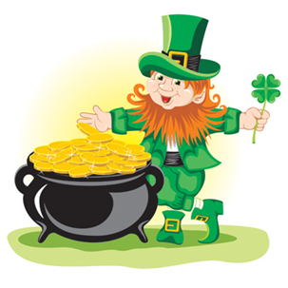
If you should be walking along a wooded path some moonlit night in Spring and hear the faint tap-tapping of a tiny hammer, you might be lucky enough to catch a glimpse of an Irish leprechaun, the elfin shoemaker, whose roguish tricks are the delight of Irish story-telling.
According to the legend, the leprechaun has a pot of gold hidden somewhere, and he must give up his treasure to the one who catches him. You'll have to step lively and think quickly to capture a leprechaun's gold though, because this sly little fellow will fool you into looking away an instant while he escapes into the forest.
A story is told of the man who compelled a leprechaun to take him to the very bush where the gold was buried. The man tied a red handkerchief to the bush in order to recognize the spot again and ran home for spade. He was gone only three minutes, but when he returned to dig, there was a red handkerchief on every bush in the field.
As long as there are Irishmen to believe in the "little folk," there will be leprechauns to reflect the wonderful Irish sense of fun, and many a new story of leprechaun shenanigans will be added to Irish folklore each year.

Leprechauns are known for
  - playing tricks on people.
  - having lots of gold.
  - making really good shoes.

Task 8. Shark threat
Is it true that Australia has more shark attacks that anywhere else?
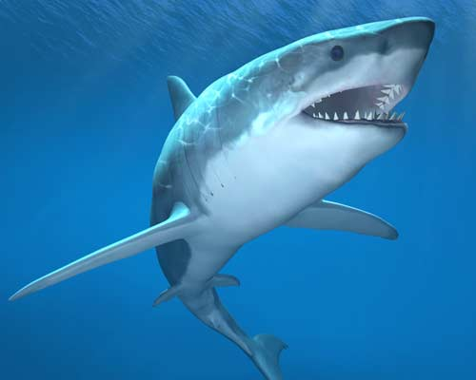
There have been 861 attacks in the U.S. and 294 in Australia. But shark attacks are rare.
Every year around the world 150 people die when a coconut falls on their head.
Which is probably true according to the text?
- You have more chances to be killed by a coconut than a shark.
- There are more sharks living off the American coast than the Australian one.
- It's more dangerous to swim in America than in Australia.
- More people die in America than in Australia.

Task 9. Discovering Tasmania

- Read the tourist information leaflet about a trip to Tasmania.

Which sentences are true?
  - You have to go for a walk on each day of the tour.
  - The tour operator only does tours on foot.
  - The group cooks meals together.
  - All equipment is provided by the tour operator.
  - Visitors are met at their accommodation.
  - The trip ends where it began.
  - There is more than one guide for each tour.

