Разработка к уроку английского языка в 3 классе
«Итоговый контроль знаний, умений и навыков»

Выполнил
учитель англ. языка
Пигаркина Л.С.

2018 год

- Tick v true. Cross x false. Then correct the false sentences.
(v верно, x неверно. Затем исправь неверные предложения.)
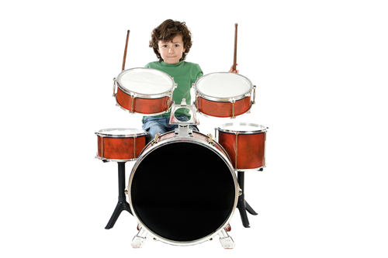

My name`s Jack. I`ve got a very clever family. My dad can play the piano and my grandma can sing very well. My mum and dad can speak Spanish. My mum`s great. She can play computer games. My sister can dance but she can`t dance very well. She`s only four. And I can lay the drums! I`m fantastic!

- Jack`s dad can play the guitar. X
- His grandma can sing very well. _
- Jack`s mum and dad can speak Spanish. _
- His mum can`t play computer games. _
- Jack`s sister can dance very well. _
- Jack can play the drums. _

Jack`s dad can play the piano. ……………………………………………………………………………...
……………………………………………………………………………………………………………………………….
……………………………………………………………………………………………………………………………….

- Complete. Use him or her.
(Дополни предложения. Используй him или her)

- Look! There`s Mike. Can you see him ?
- Suzie is my new classmate. I really like ____.
- John is in the park. His dog is with ____.
- Mary isn`t at school today. What`s wrong with ____?
- Do you know the tall boy in the pop group? I`m crazy about ___.
- She`s got my biscuits. Stop …….!

- Circle the correct words. (Обведи правильные слова)

Alex Do you like pop music?
Olga Yes, I ¹….. . I`m crazy about pop music!
Alex Can you sing?
Olga Yes, I ²…. . I can sing ³… .
Alex Are you in a pop ⁴…. ?
Olga Yes, I am. I`m the singer in Teens. My sister is in group, too. She plays ⁵….. guitar. Look, here`s a poster of the group. That`s my sister and I`m next to ⁶… .

1 a do b am
2 a do b can
3 a very good b very well
4 a group b family
5 a a b the
6 a him b her

- Read and draw the path. Then tick V the correct house.
(Прочитай и нарисуй тропинку. Отметь галочкой правильный дом)

Start at the bus stop. Turn left and go straight on. Then turn right at the trees. Go straight on to the big house and turn left. Go straight on and turn right. Where are you?

1 Mike`s house
2 Maria`s house
3 Jamie`s house

- Complete the questions and answers.
(Дополни вопросы и ответы)

0 - ..Do.. you like milk? – No, I …don`t… .
1 - ……… you like chips? – Yes, I ….. .
2 - ………… your best friend like hamburgers? – Yes, he ….. .
3 - …………. your English teacher like tea? – No, she ….. …. .
4 - ……….. you like cola? – No, I ….. .

- Write the times. (Напиши время)

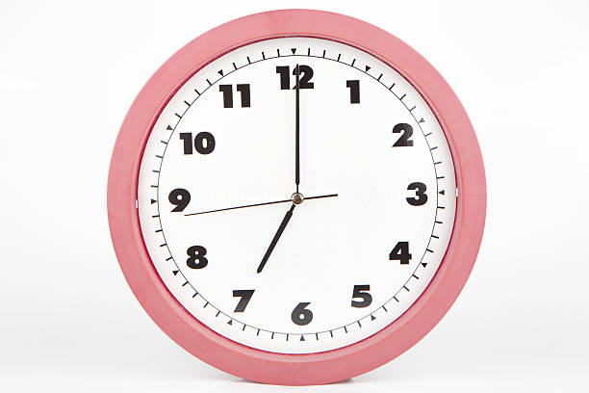 1 It`s seven o`clock.

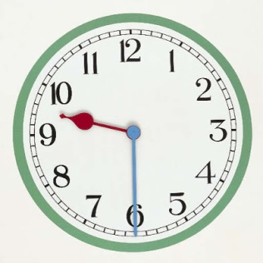 2 …………………………………………..

3 ……………………………………………...

4 …………………………………………………

5 …………………………………………….

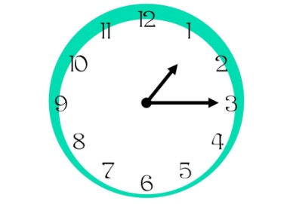6 …………………………………………………

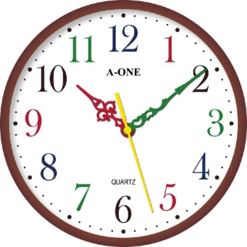 7 ……………………………………………………

Список использованной литературы:

- Skinner Carol: «Friends. Starter» // C. Skinner // Pearson Education Limited, England. – 2010. – 95 P.
- Skinner Carol: «Friends. Starter Activity Book» // C. Skinner // Pearson Education Limited, England. – 2009. – 63 P.

Список электронных источников:

- https://yandex.ru/images/search?img_url=https%3A%2F%2Fstatic8.depositphotos.com%2F1465849%2F943%2Fi%2F950%2Fdepositphotos_9433495-stock-photo-child-playing-a-drum.jpg&p=1&text=%D0%BC%D0%B0%D0%BB%D1%8C%D1%87%D0%B8%D0%BA%20%D0%B8%D0%B3%D1%80%D0%B0%D0%B5%D1%82%20%D0%BD%D0%B0%20%D0%B1%D0%B0%D1%80%D0%B0%D0%B1%D0%B0%D0%BD%D0%B0%D1%85%20%D0%B7%D0%B0%D1%80%D0%B8%D1%81%D0%BE%D0%B2%D0%BA%D0%B0&pos=37&lr=14&rpt=simage
(мальчик за барабанной установкой)

- https://yandex.ru/images/search?text=7%20%D1%87%D0%B0%D1%81%D0%BE%D0%B2%20%D0%BA%D0%B0%D1%80%D1%82%D0%B8%D0%BD%D0%BA%D0%B0&img_url=https%3A%2F%2Fmedia.istockphoto.com%2Fphotos%2Fquarter-past-six-oclock-picture-id506916986&pos=6&rpt=simage&lr=14&family=yes
(7 часов)

- https://yandex.ru/images/search?text=9%3A30%20%20%D1%87%D0%B0%D1%81%D0%BE%D0%B2%20%D0%BA%D0%B0%D1%80%D1%82%D0%B8%D0%BD%D0%BA%D0%B0&img_url=http%3A%2F%2Fwww.clipartmasters.com%2Fclip-arts%2F626%2Fanalog-clock-626905.jpg&pos=0&rpt=simage&lr=14&family=yes
  - асов)

- https://yandex.ru/images/search?text=2%20%D1%87%D0%B0%D1%81%D0%B0%20%D0%BA%D0%B0%D1%80%D1%82%D0%B8%D0%BD%D0%BA%D0%B0&img_url=https%3A%2F%2Fkak2z.ru%2Fmy_img%2Fimg%2F2016%2F03%2F09%2F8e6aa.jpg&pos=15&rpt=simage&lr=14&family=yes
(2 часа)

5. https://yandex.ru/images/search?text=11%3A30%20%D1%87%D0%B0%D1%81%D0%B0%20%D0%BA%D0%B0%D1%80%D1%82%D0%B8%D0%BD%D0%BA%D0%B0&img_url=https%3A%2F%2Fus.123rf.com%2F450wm%2Fthavornc%2Fthavornc1508%2Fthavornc150800105%2F44187137-%25D0%2598%25D0%25B7%25D0%25BE%25D0%25BB%25D0%25B8%25D1%2580%25D0%25BE%25D0%25B2%25D0%25B0%25D0%25BD%25D0%25BD%25D1%258B%25D0%25B5-%25D1%2587%25D0%25B0%25D1%2581%25D1%258B%2C-%25D0%25BF%25D0%25BE%25D0%25BA%25D0%25B0%25D0%25B7%25D1%258B%25D0%25B2%25D0%25B0%25D1%258E%25D1%2589%25D0%25B8%25D0%25B5-9%3A30-%25D1%2587%25D0%25B0%25D1%2581%25D0%25BE%25D0%25B2.jpg%3Fver%3D6&pos=10&rpt=simage&lr=14&family=yes
(11.30)

https://yandex.ru/images/search?text=17%3A30%20%D1%87%D0%B0%D1%81%D0%B0%20%D0%BA%D0%B0%D1%80%D1%82%D0%B8%D0%BD%D0%BA%D0%B0&img_url=https%3A%2F%2Fds04.infourok.ru%2Fuploads%2Fex%2F0b8e%2F0007859d-ab2865e8%2Fhello_html_m4da53086.png&pos=2&rpt=simage&lr=14&family=yes
(17.30)

https://yandex.ru/images/search?text=17%3A30%20%D1%87%D0%B0%D1%81%D0%B0%20%D0%BA%D0%B0%D1%80%D1%82%D0%B8%D0%BD%D0%BA%D0%B0&img_url=https%3A%2F%2Fwww.flashcardcloud.com%2F%5CImageUpload%5C4adb2e19-13b0-4a88-bb32-5a3b2f5afda6%5Cch2.jpg&pos=8&rpt=simage&lr=14&family=yes
(15.15)

https://yandex.ru/images/search?text=17%3A30%20%D1%87%D0%B0%D1%81%D0%B0%20%D0%BA%D0%B0%D1%80%D1%82%D0%B8%D0%BD%D0%BA%D0%B0&img_url=https%3A%2F%2Foombs.files.wordpress.com%2F2013%2F07%2Fwall_clock.jpg&pos=10&rpt=simage&lr=14&family=yes
(10.10)

